**User Manual**

**for**

**DigiCampus**

**Version 2.0**

**Prepared by**

**Group #: 1 Group Name: Achievers**

|  |  |  |
| --- | --- | --- |
| **Dishay Mehta** | **200341** | **dishaymehta952@gmail.com** |
| **Abhishek Pardhi** | **200026** | **abhipardhi326@gmail.com** |
| **Samarth Arora** | **200849** | **samartharora03@gmail.com** |
| **Ankur Kumar** | **200140** | **ankurrk04@gmail.com** |
| **Shashwat Gupta** | **200923** | **guptashashwatme@gmail.com** |
| **Ananya Agrawal** | **200117** | **ananyaagrawal704@gmail.com** |
| **Girik Maskara** | **200387** | **girikmaskara552002@gmail.com** |
| **Sarthak Kohli** | **200886** | **sarthak811kohli@gmail.com** |
| **Aayush Kumar** | **200008** | **aayushk0072@gmail.com** |
| **Aryan Vora** | **200204** | **aryanvora23@gmail.com** |

|  |  |
| --- | --- |
| **Course:** | **CS253** |
| **Mentor TA:** | ***Aman*** |
| **Date:** | **04/04/22** |

**Contents 1**

**Revisions 2**

**1** **Introduction 3**

**2 Student 3**

**3** **Mess Manager 16**

**4 Security Guard 21**

**Appendix A - Group Log 25**

**Revisions**

| **Version** | **Primary Author(s)** | **Description of Version** | **Date Completed** |
| --- | --- | --- | --- |
| 1.0 | Dishay Mehta,Abhishek Pardhi,Samarth Arora,Ankur Kumar,Shashwat Gupta,Ananya Agarwal,Girik Maskara,Sarthak Kohli,Aayush Kumar,Aryan Vora | Version 1.0 completed | 04/04/22 |
| 2.0 | Dishay Mehta,Abhishek Pardhi,Samarth Arora,Ankur Kumar,Shashwat Gupta,Ananya Agarwal,Girik Maskara,Sarthak Kohli,Aayush Kumar,Aryan Vora | Updated to Version 2.0 | 28/04/22 |

***Introduction:*** DigiCampus is an application designed to be used by IITK students. It allows two main functionalities, a digitalized system to track entry and exit from hall gates and a digital register that keeps track of the extras that can be bought at the mess. The application aims to make hall entry and exit smoother, faster, and hassle-free, while also bringing transparency to the system that is currently in place in the hall messes.

DigiCampus will have three **profile classes**: *students, security guards, and mess managers*. These profiles will get access to relevant information and features.

**Creating a User:**

1. **Login to DigiCampus Admin Account**

**Step 1:** Access Admin Account at <https://digi-campus.herokuapp.com/admin/>

**Step 2**: You can see several tabs under Site Administration. Click on “+Add” Button in front of “Users” Tab under “Authentication and Authorisation” list.

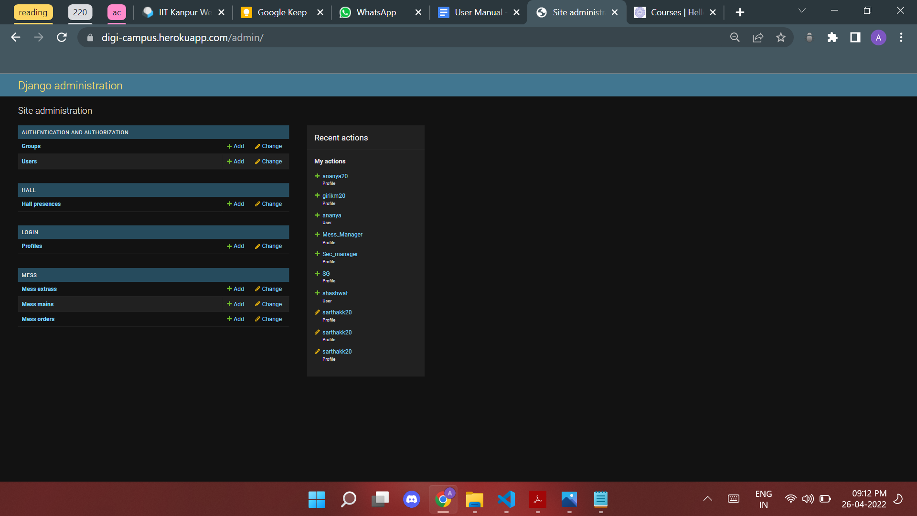

**Step 3**: Fill details (Username and Password) of new user to be created in window which looks like as shown.

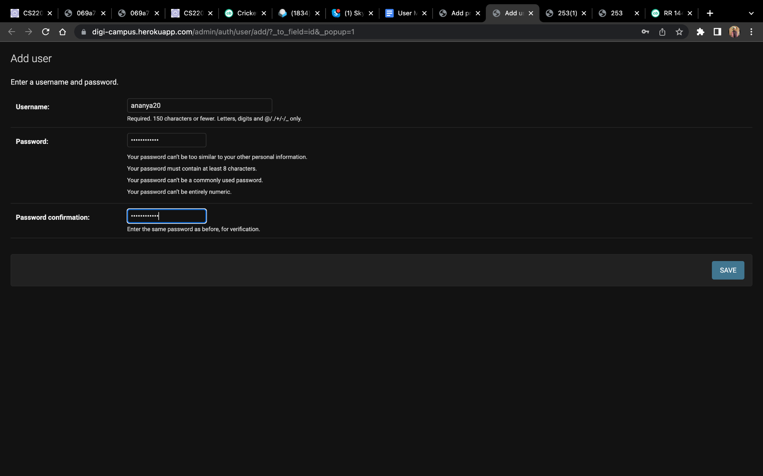

**Step 4:** Click on “Save and continue editing” button on bottom right corner.

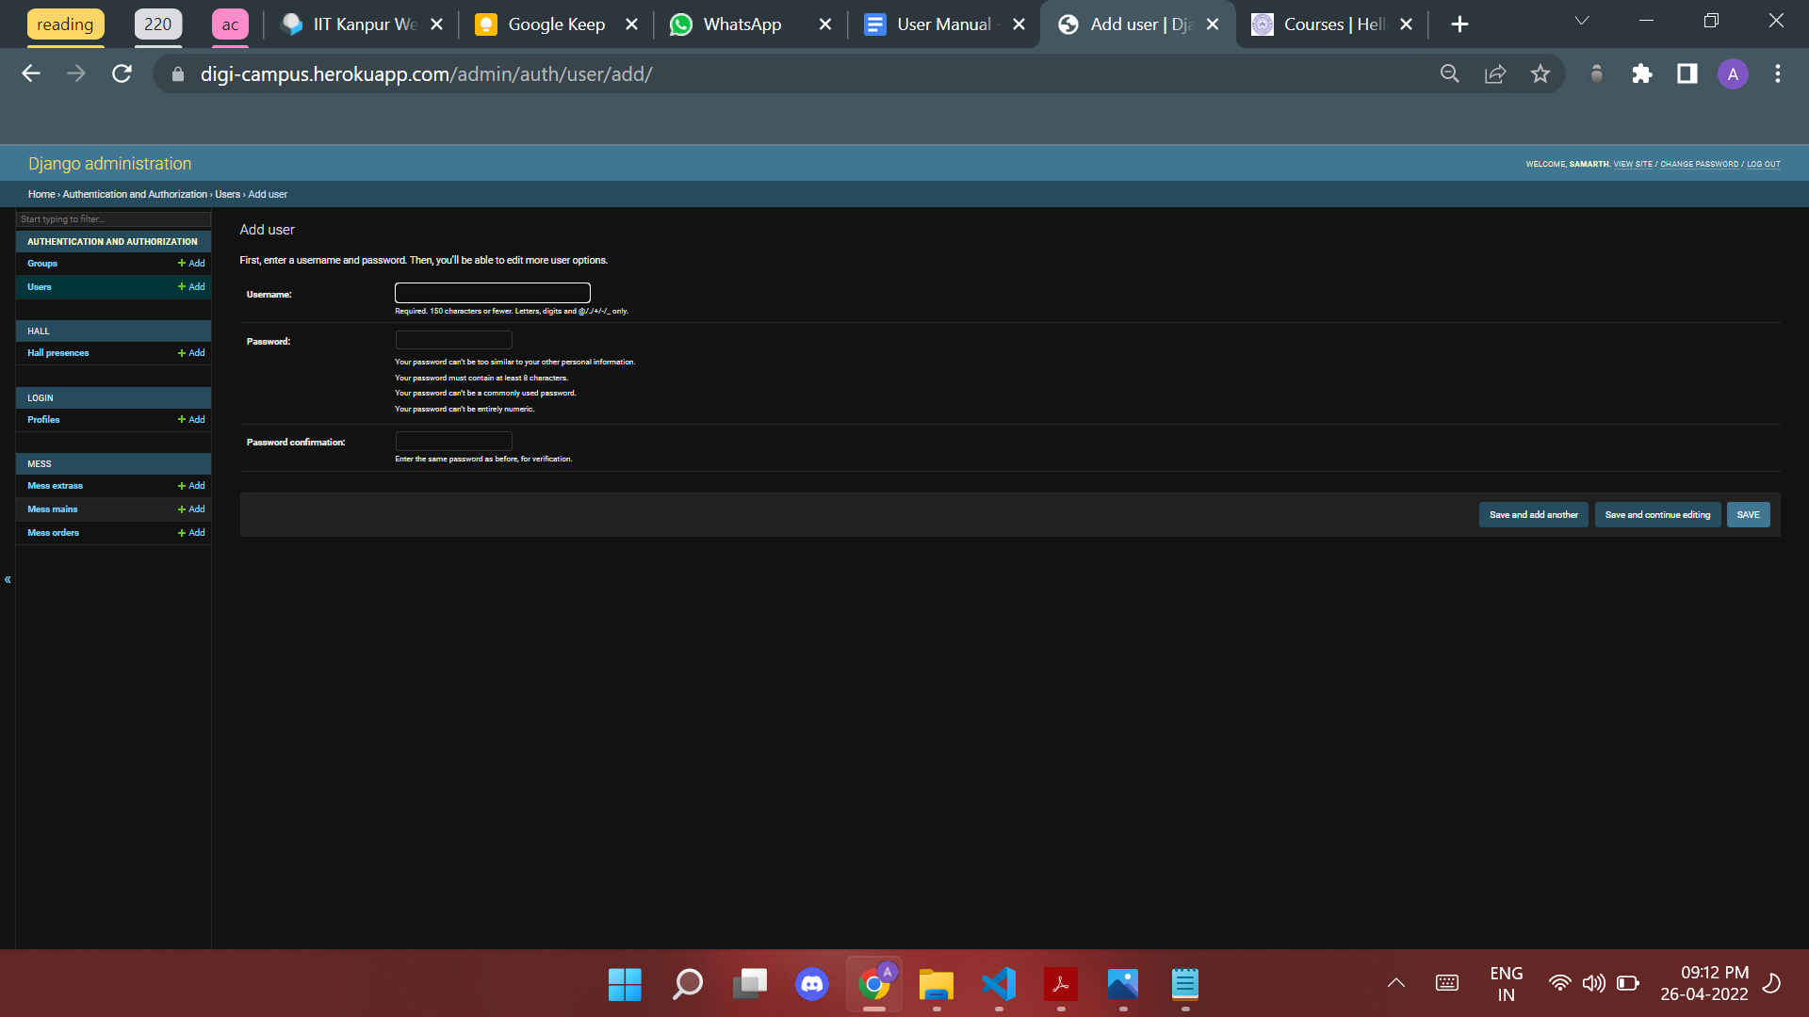

**Step 5**: On the Tab list to the left, choose “Profiles” tab under “LOGIN” list.

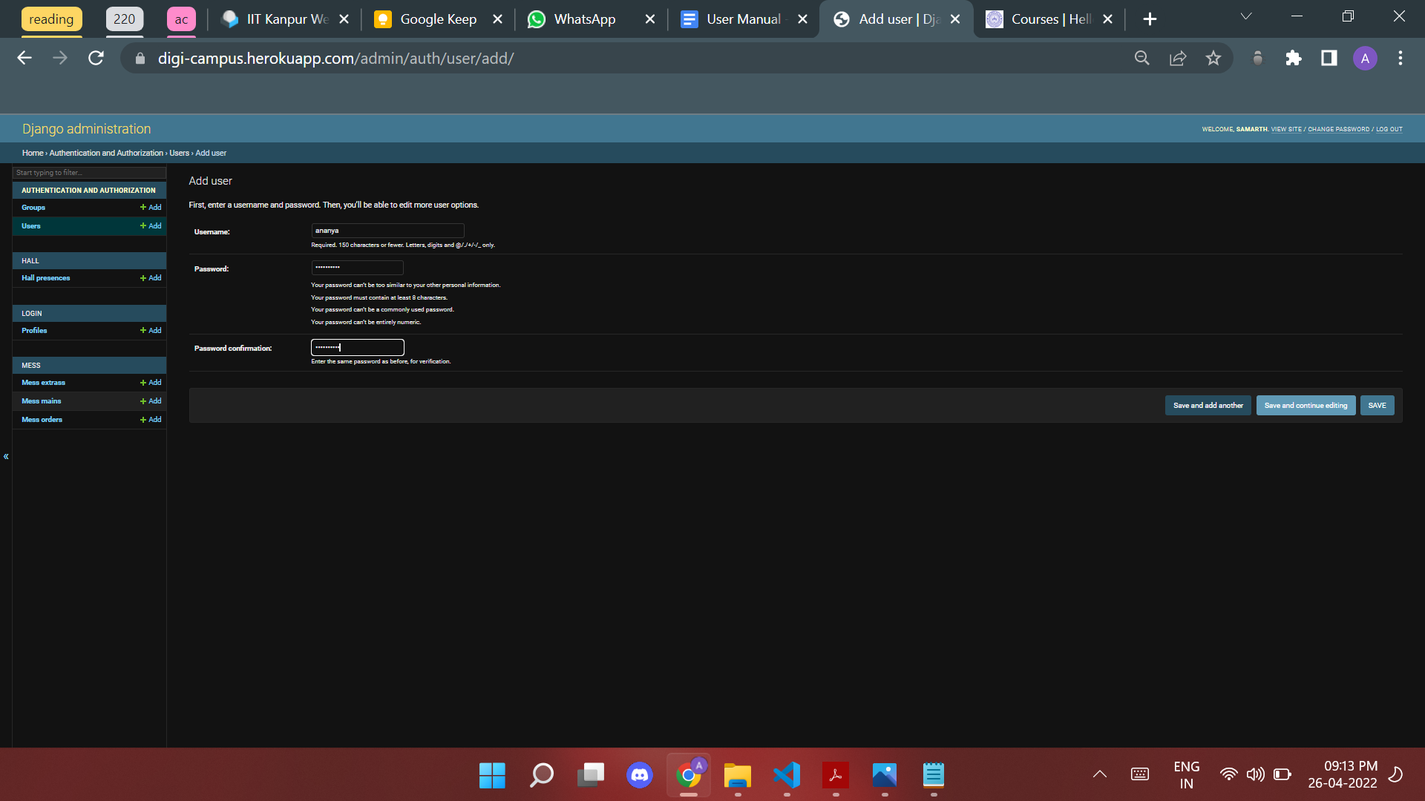

**Step 6:** Click on empty blank near “Actions” and select the newly created user from the drop-down thus appeared.

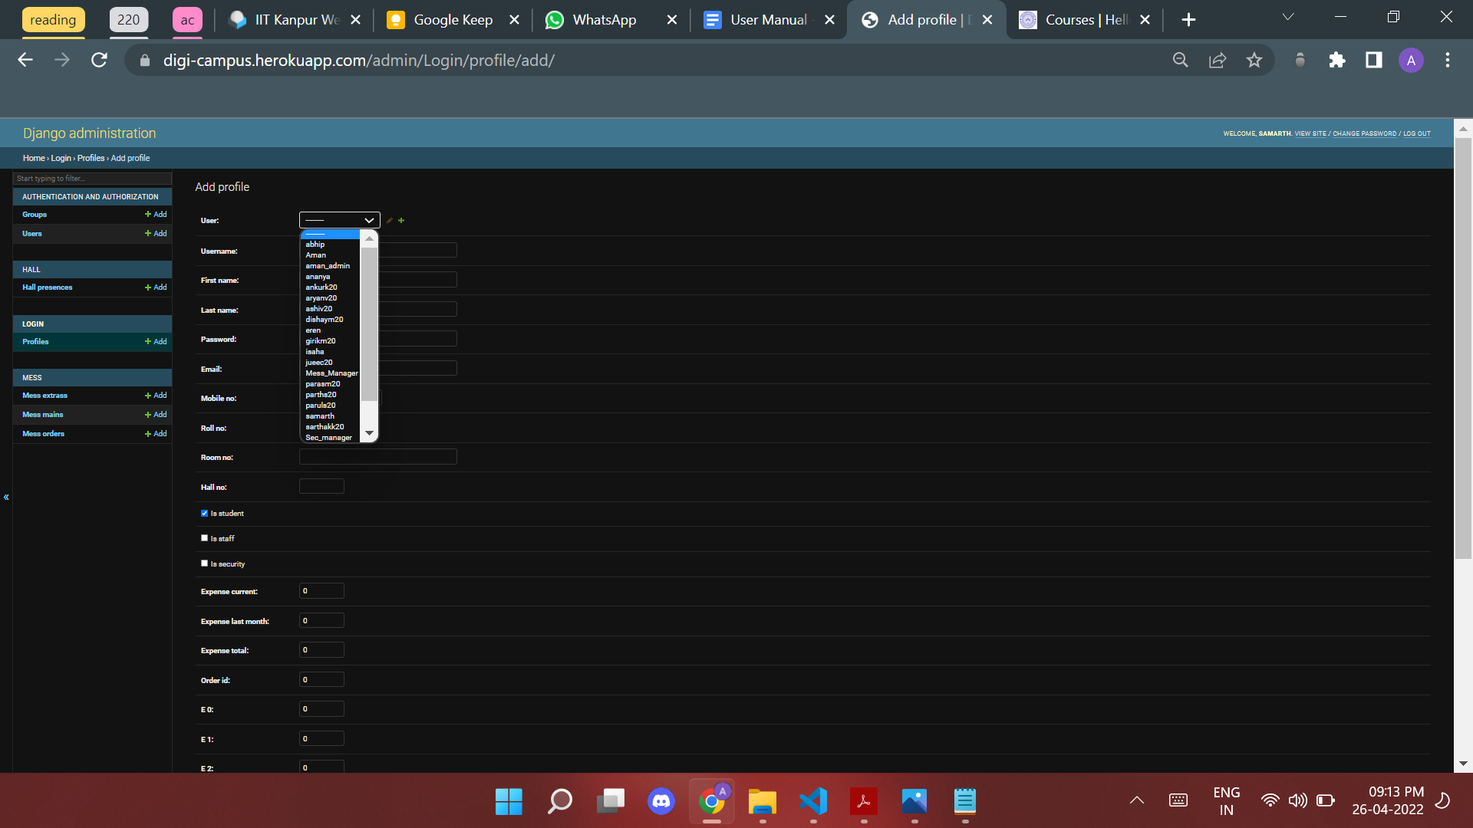

**Step 7:** On selecting name, a form of required entries for a user is shown which includes details including Hall, Mobile no., User type (student, security guard etc.), room no. etc.fi

You can select your user according to :

* student for student.
* staff for in mess staff to work on the mess page.
* security for SIS Guards to maintain entry/exit in Halls.

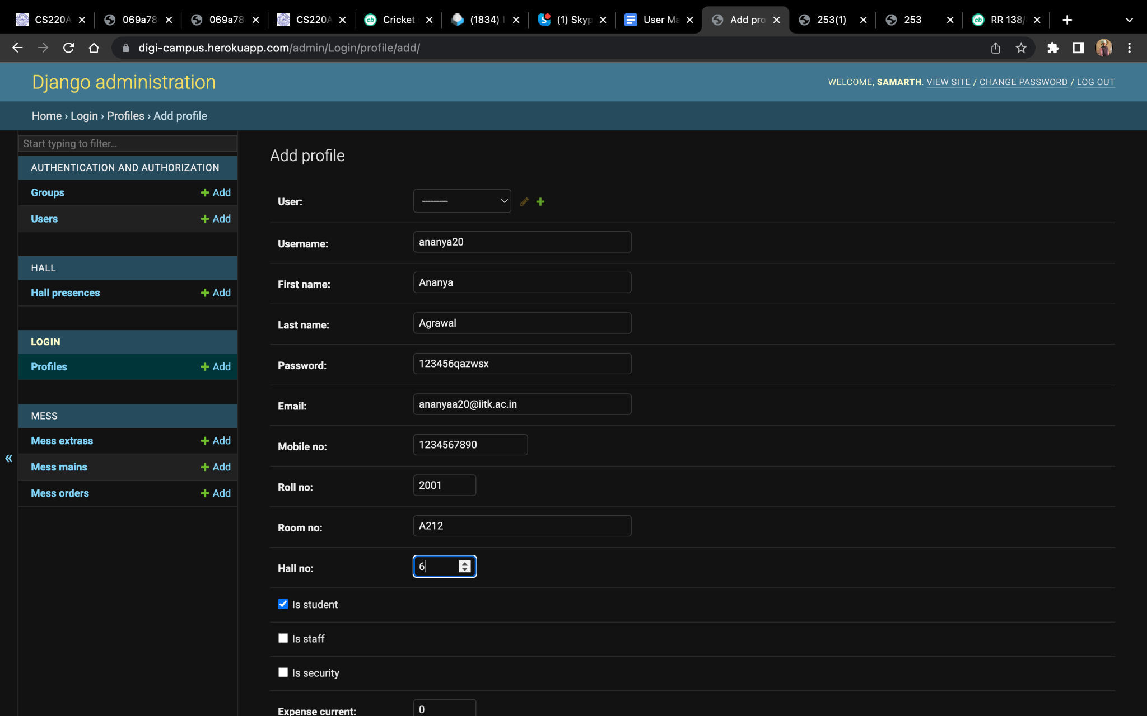

**Step 8:** Click Save and the User is created!

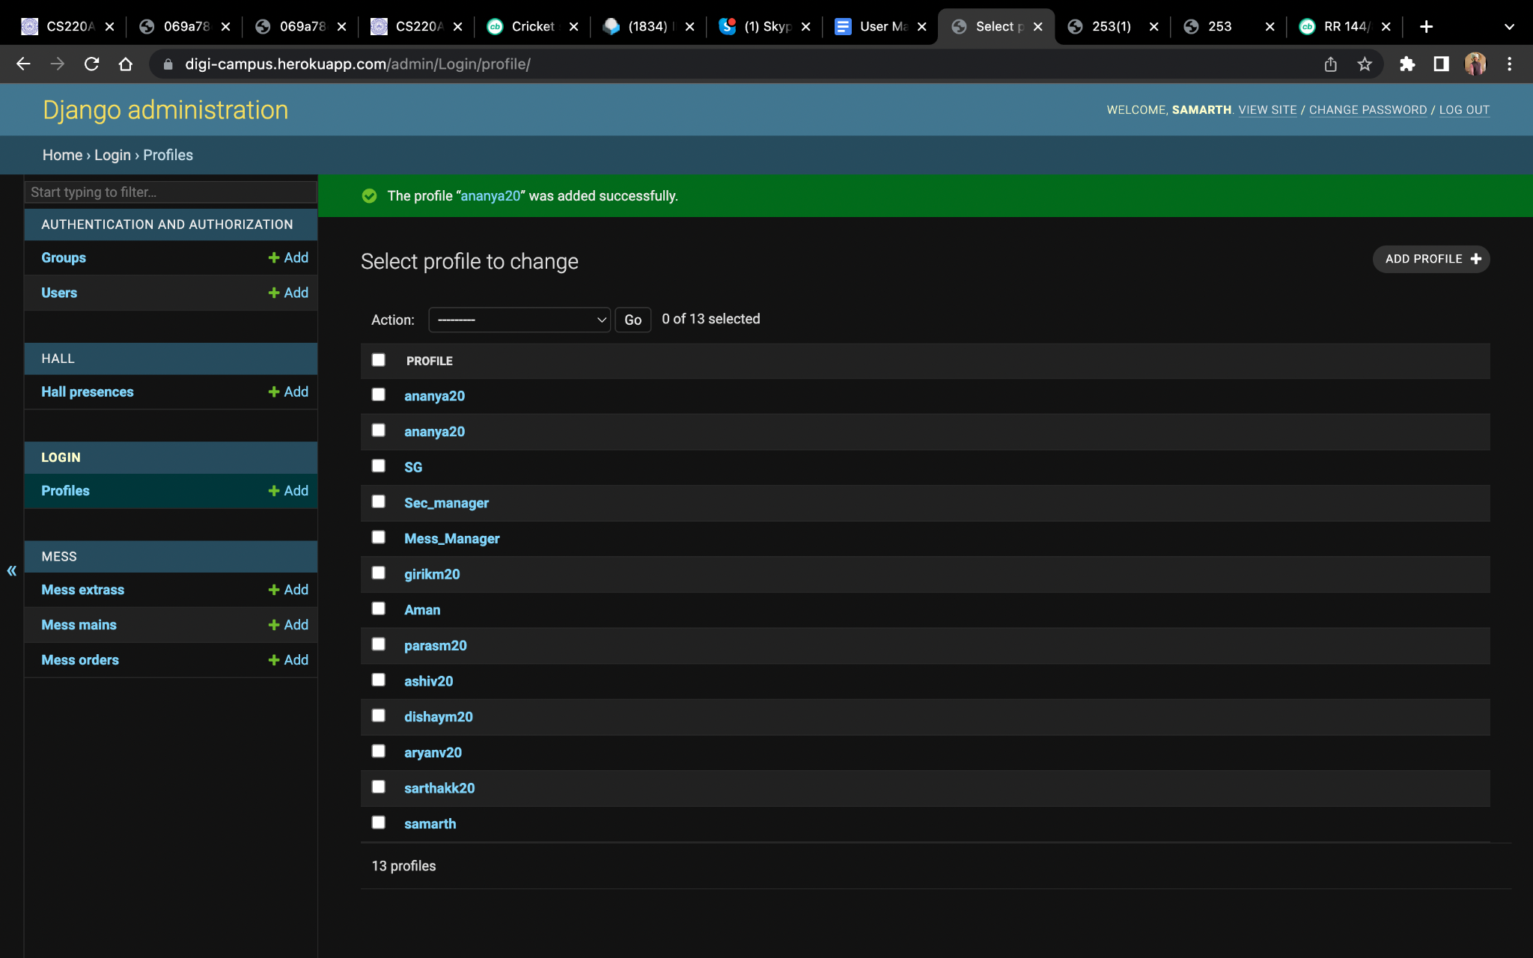

**Student**:

1. **Login to your DigiCampus Account**

The User will be provided with an initial user id and password.

**Step 1:** Access **DigiCampus** at <https://digi-campus.herokuapp.com/>

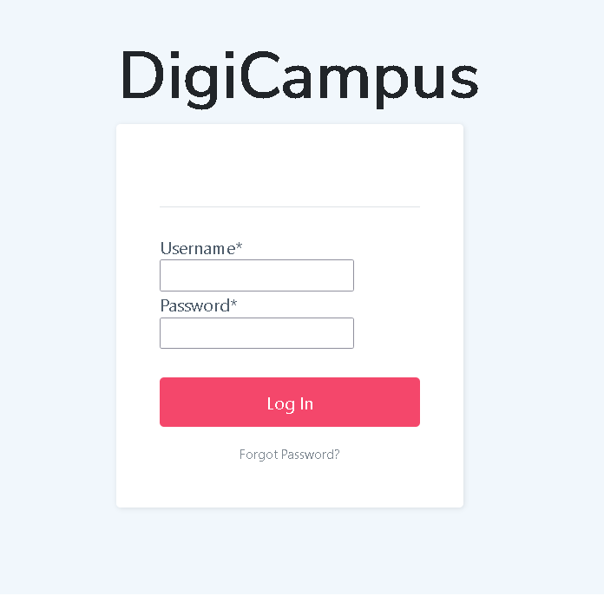

**Step 2:** Enter your *Username* and *Password*.

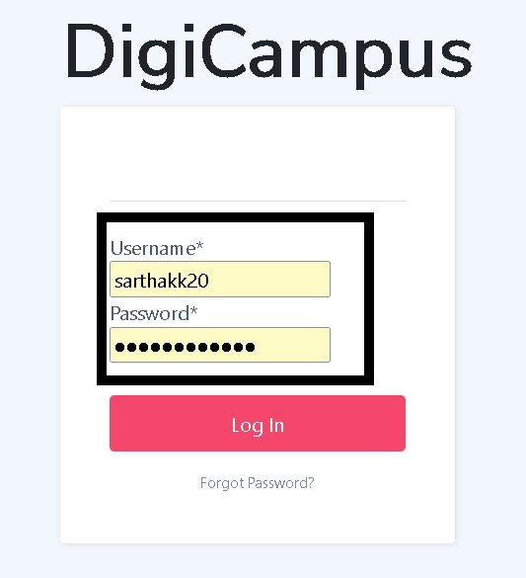

**Step 3:** Click on *Login*.

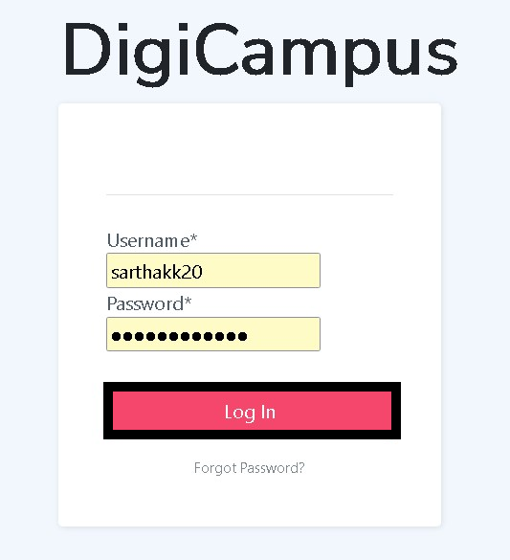

**Note:** In case of no input or incorrect input of Username/Password, the following warning messages will pop up, respectively.

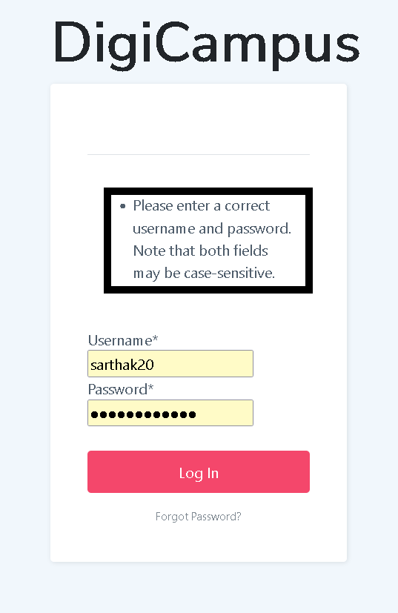 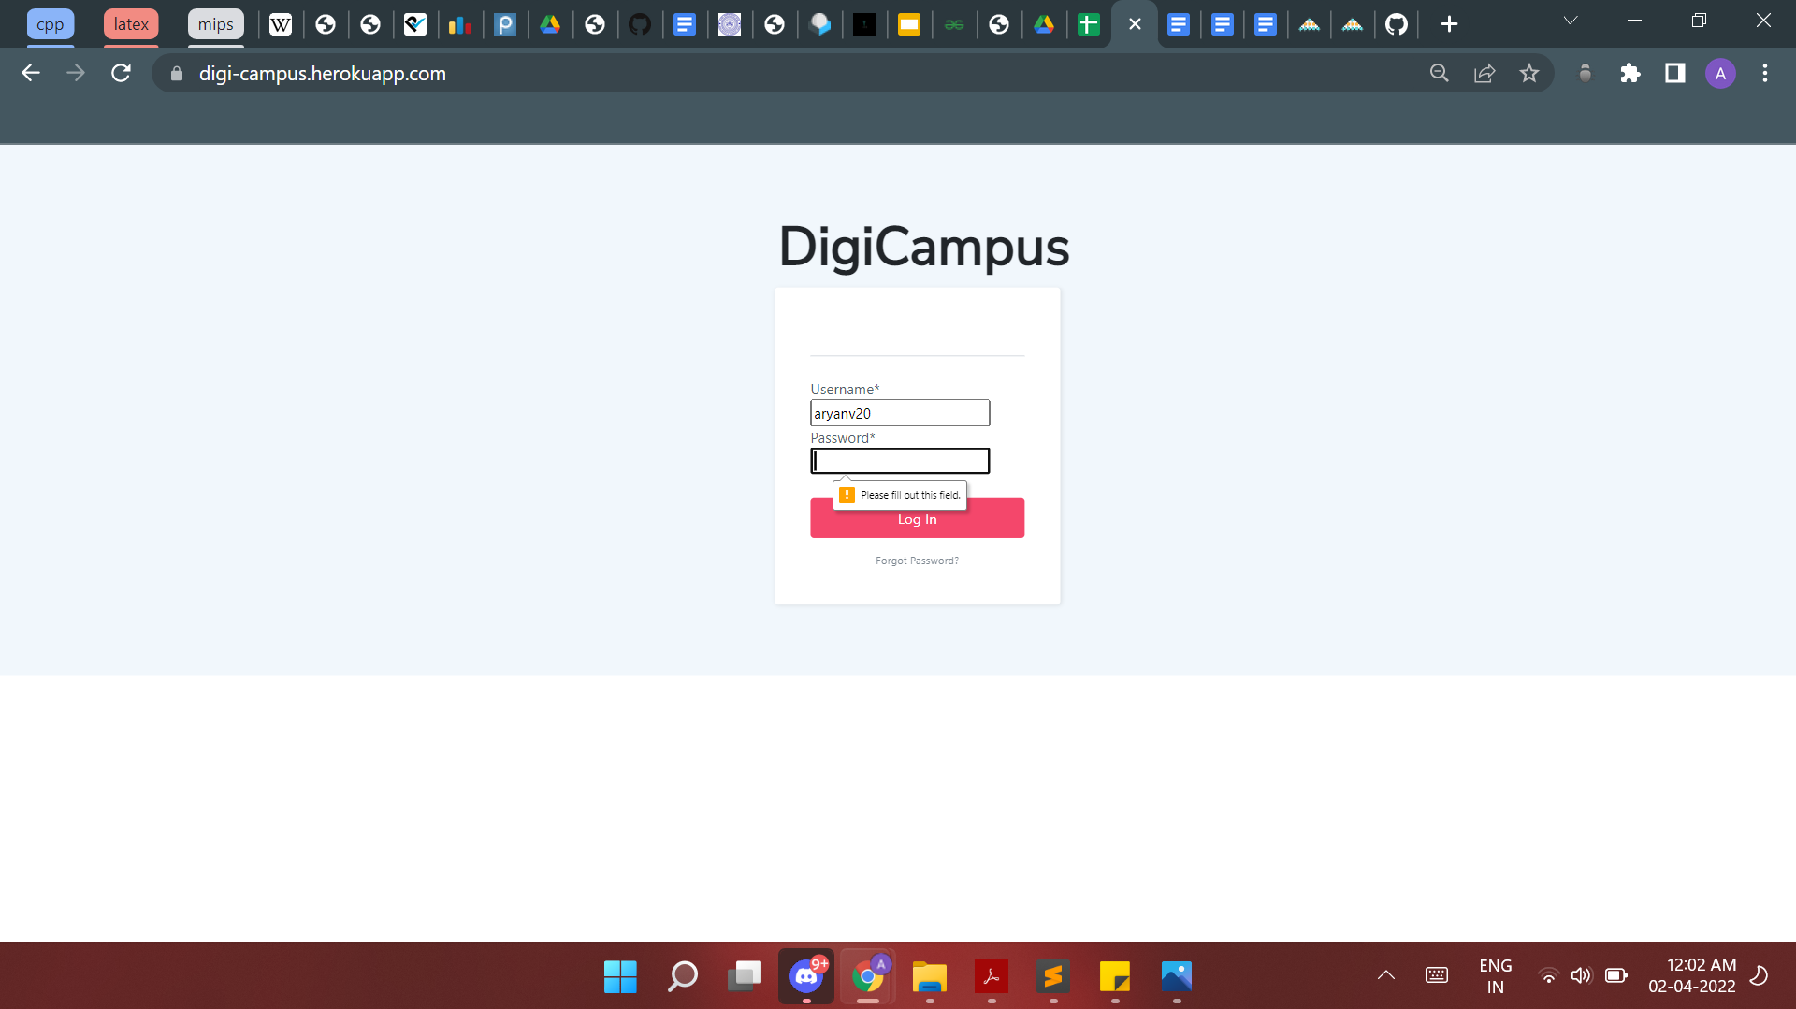

**Note:** After successful sign in, you will be redirected towards the user profile page.

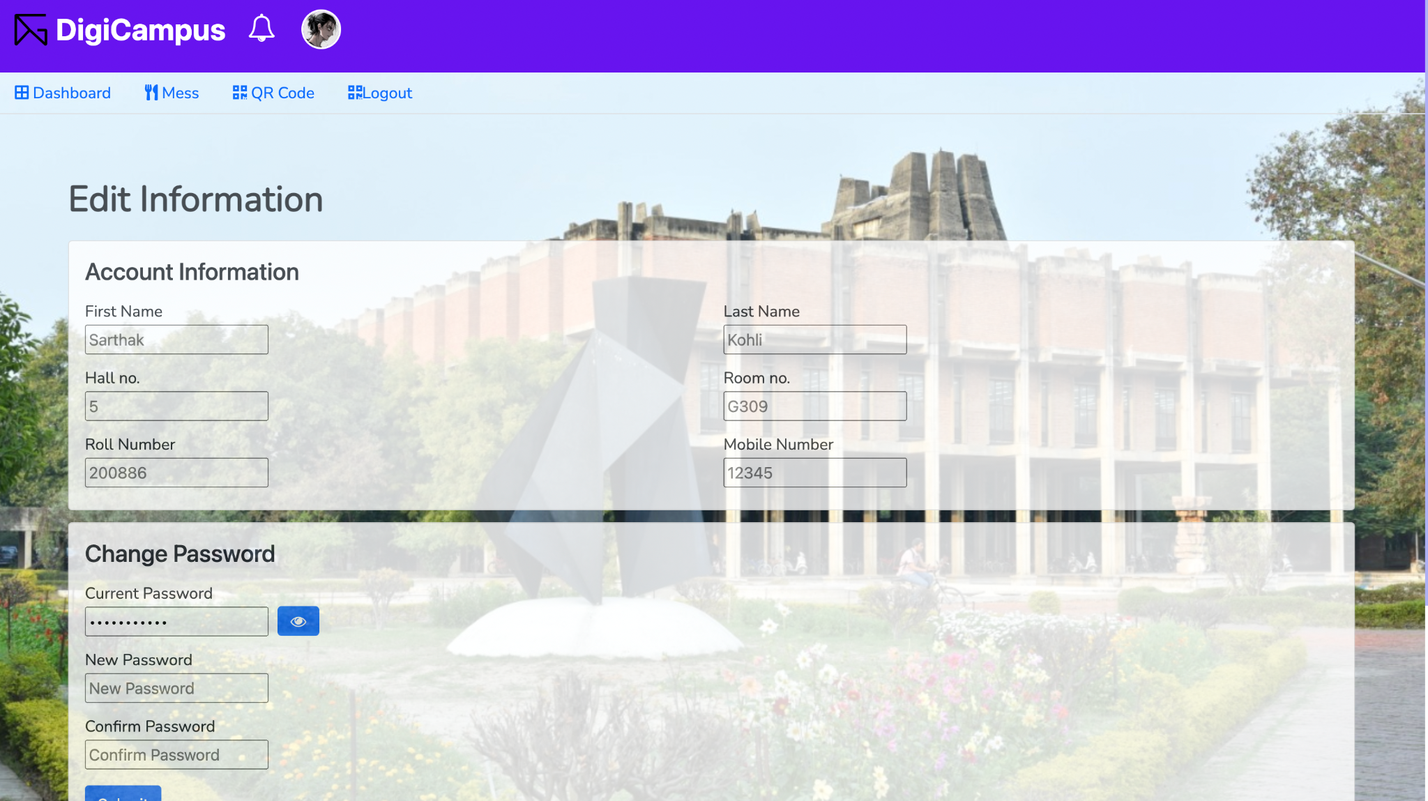

1. **Entering a Hall using DigiCampus**

**Step 1:** After signing in to Digicampus, choose *QR code* menu from the top

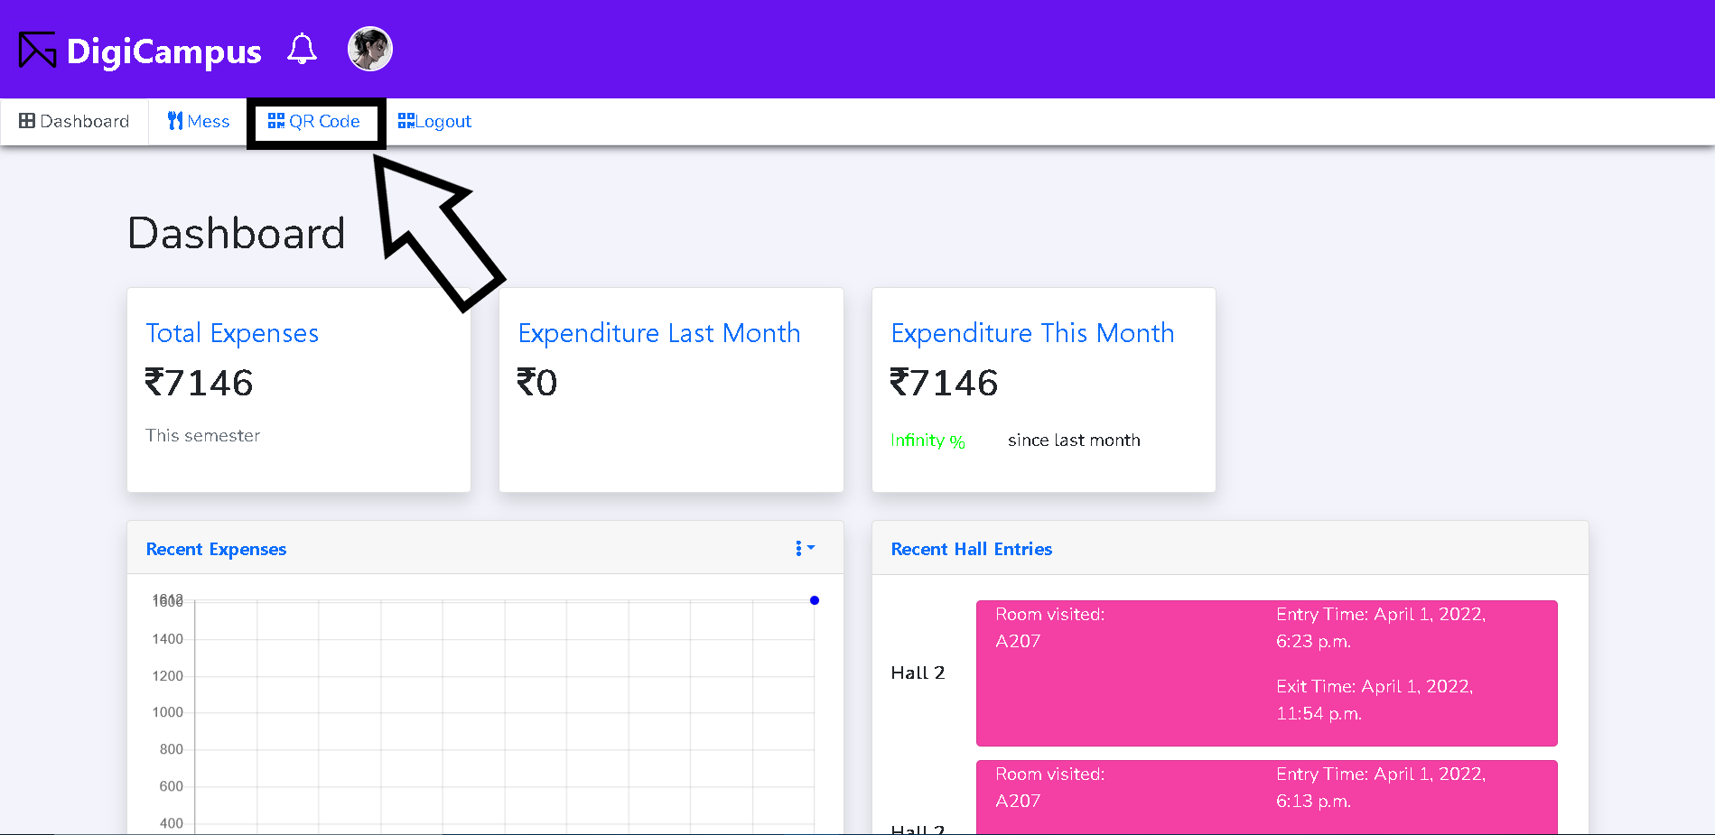

**Step 2:** Click on the *QR code* icon poping up

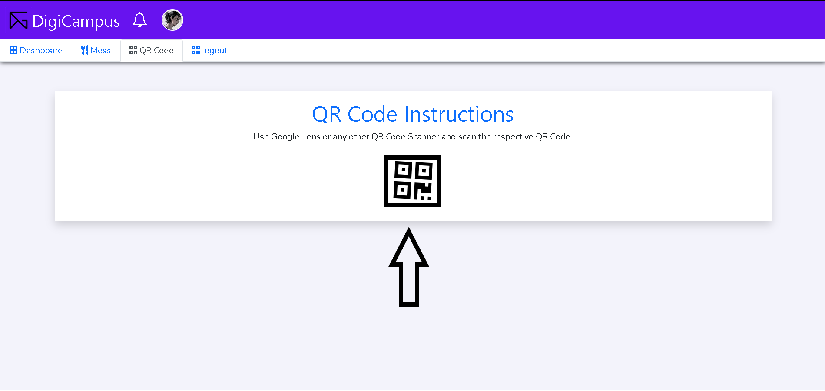

**Step 3**: Click *Allow* to give camera permissions

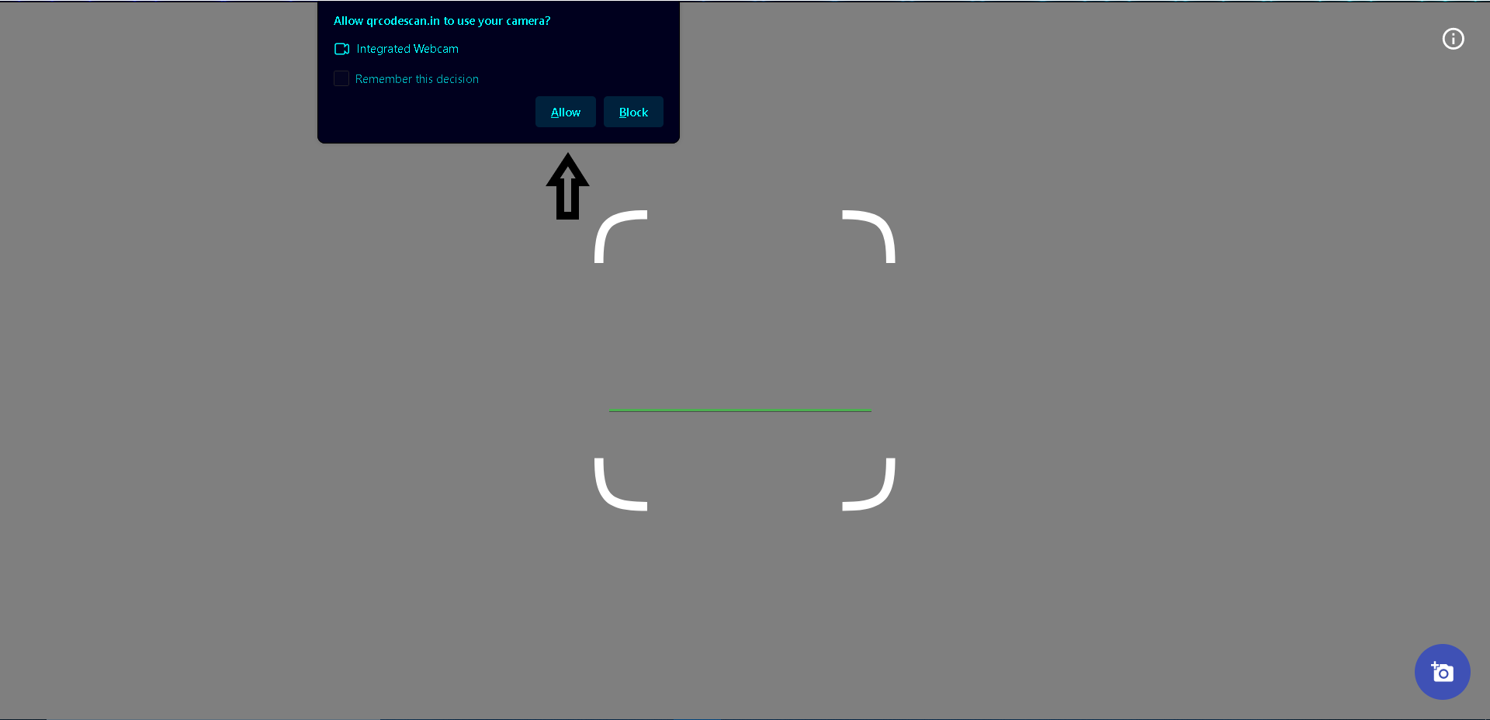

**Step 4:** *Scan* the QR code at the hall gate.

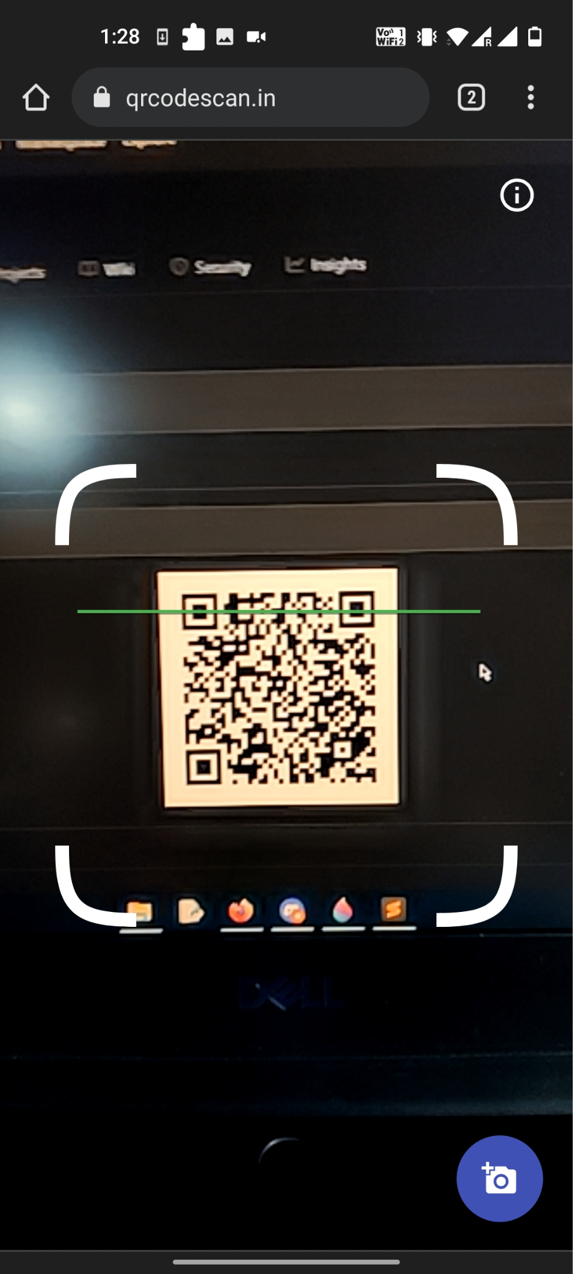

**Step 5:** Fill the *Roll Number* of the Student you are visiting and their *Room Number* correctly.

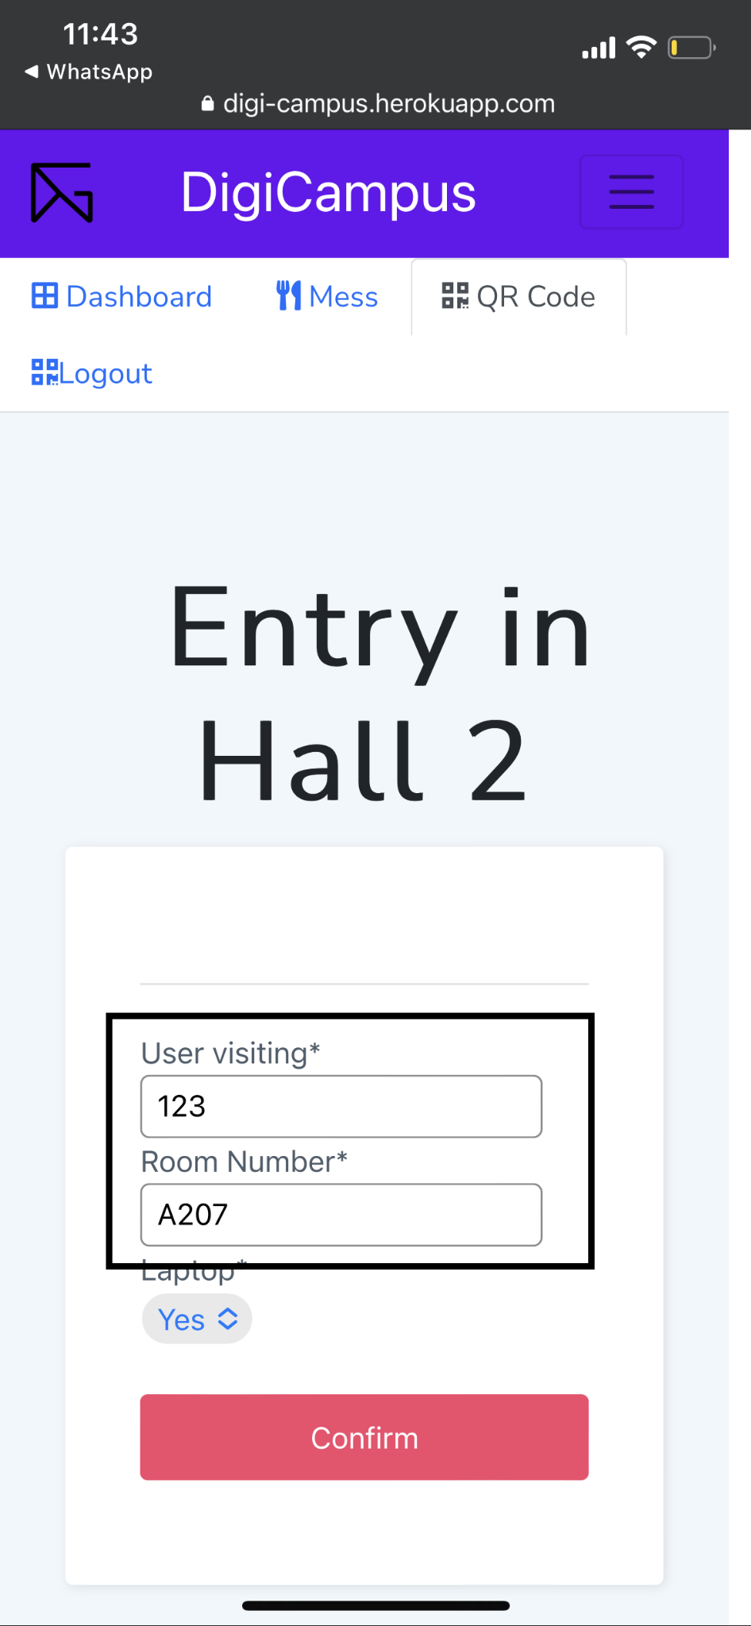

**Step 6:** Choose whether or not you are carrying a laptop.

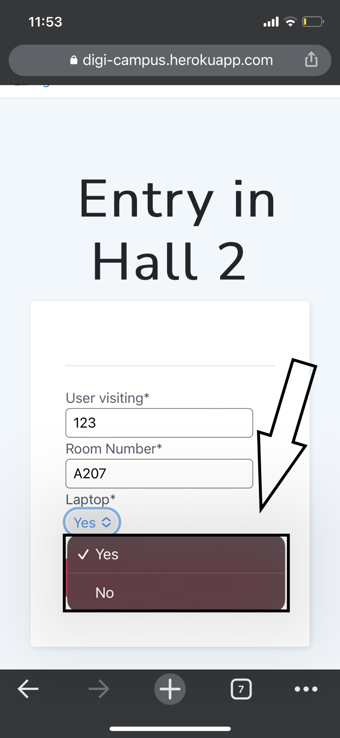

**Step 7:** Click on *Confirm*.

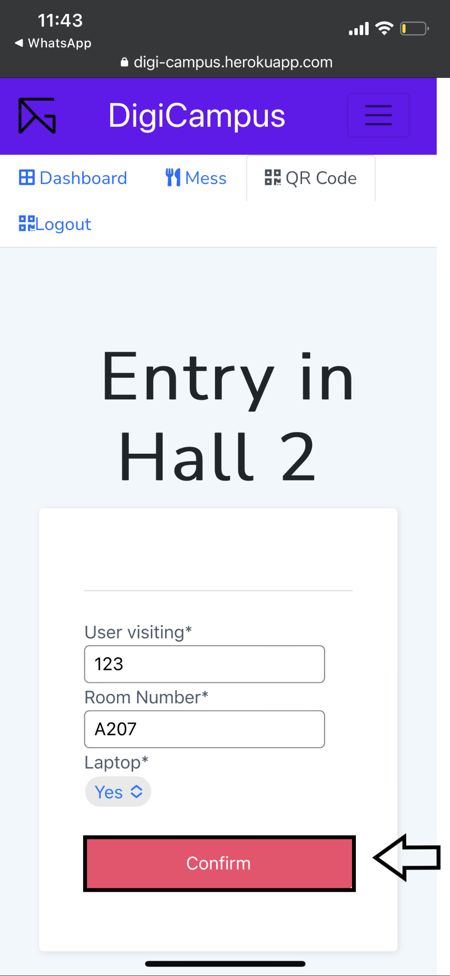

**Note:** After successful entry in hall you shall be prompted with the following.

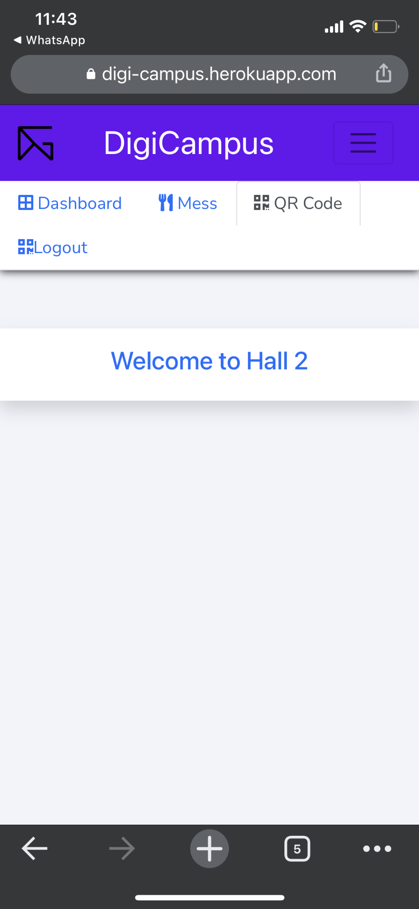

1. **Exiting out of a hall using DigiCampus**

**Steps:** Ask the hall security SIS guard to sign you out of the hall before leaving

**Note:** If you leave without getting signed out and try to sign in another hall, you will get

the following prompt.

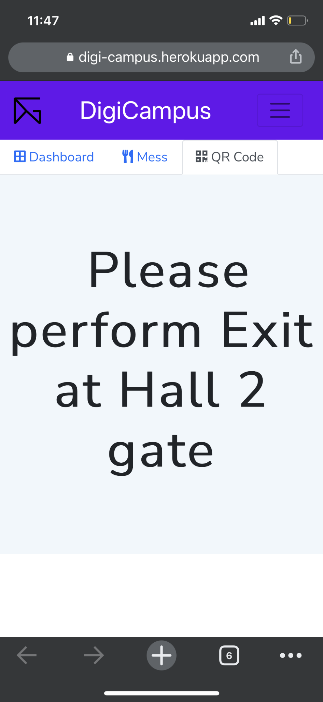

1. **Seeing Mess menu and buying extras for Every meal in Halls.**

**Step 1:** After signing in to DigiCampus, choose the *Mess* menu from the top

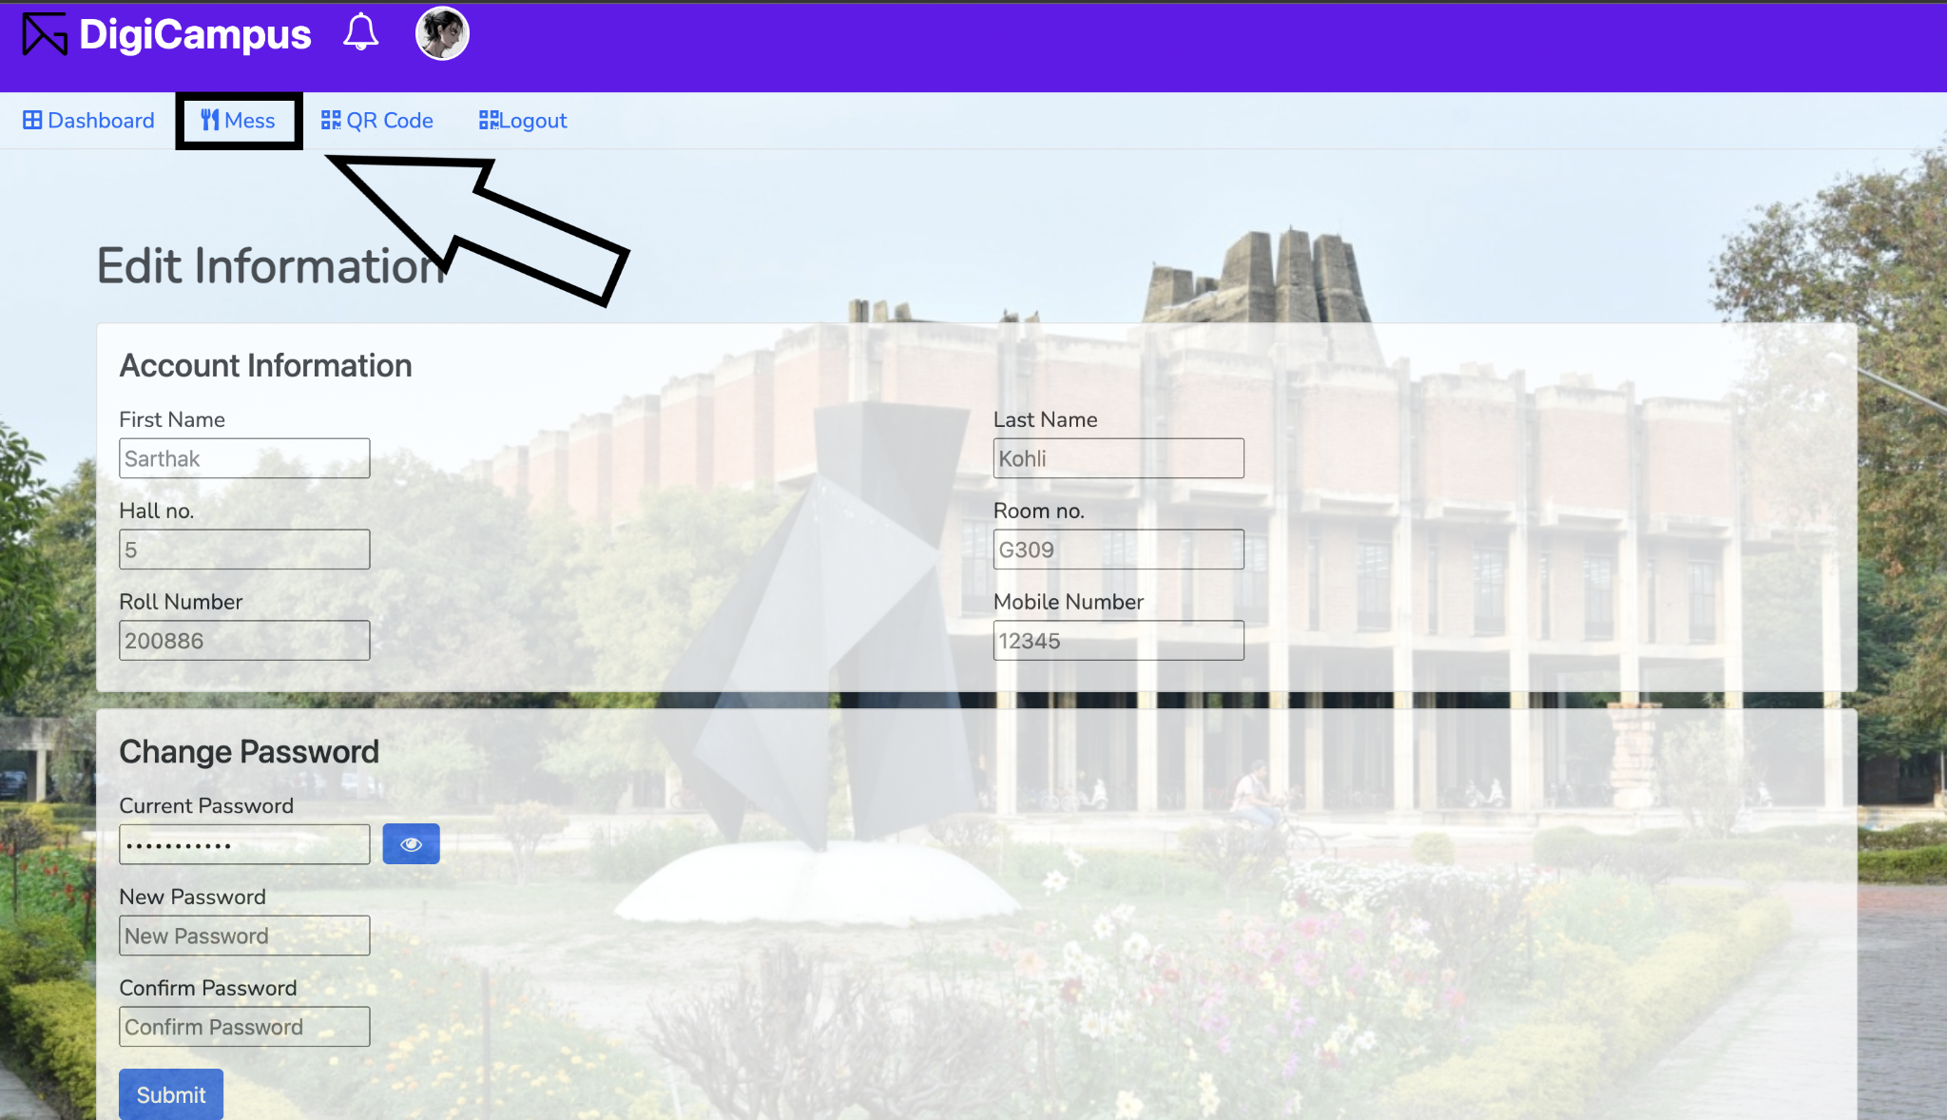

**Step 2**: Scroll on the Menu on the left to browse through the menu

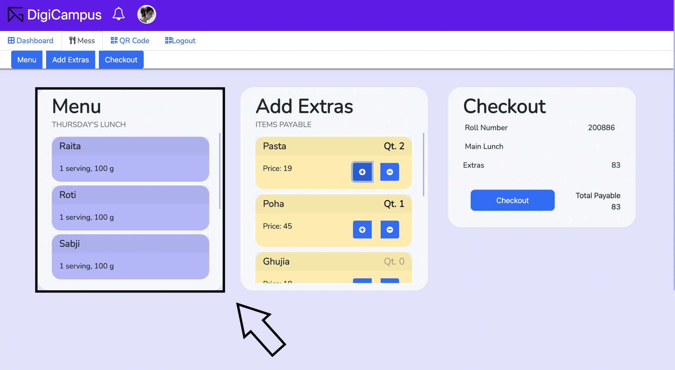

**Step 3:** To order extras, scroll to the desired food items on the extras list and add the number of items needed respectively

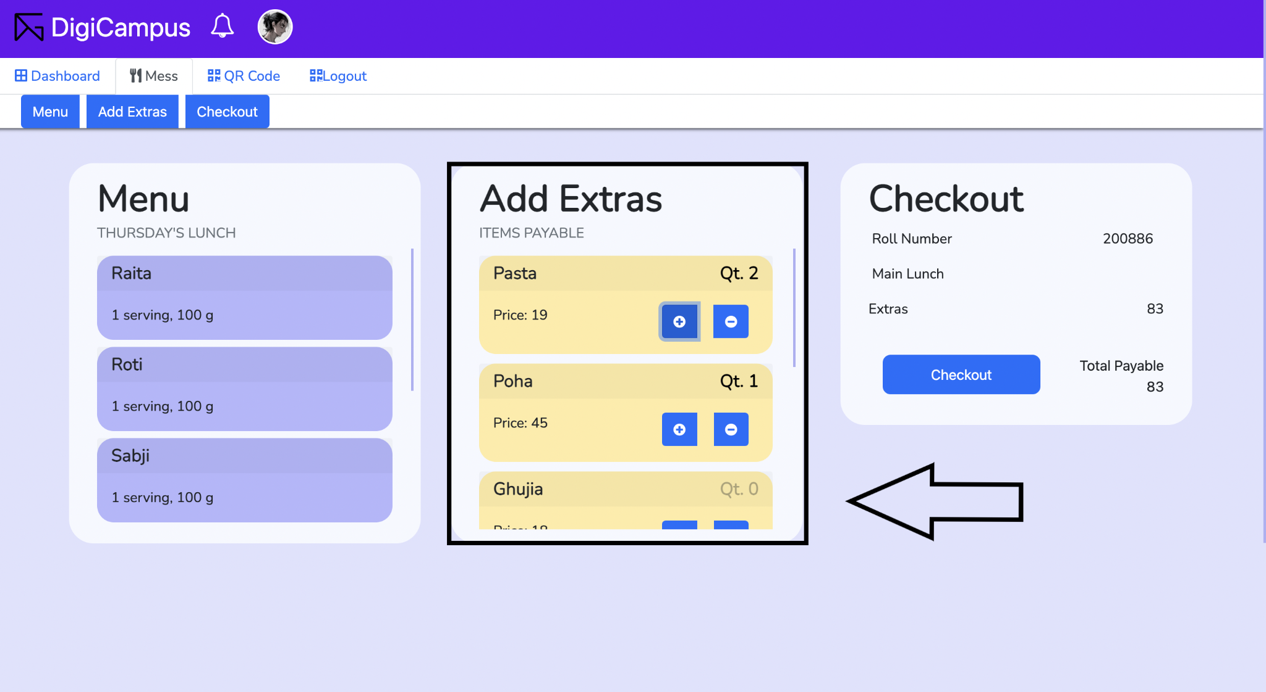

**Step 4:** Proceed to click on the *Checkout* button

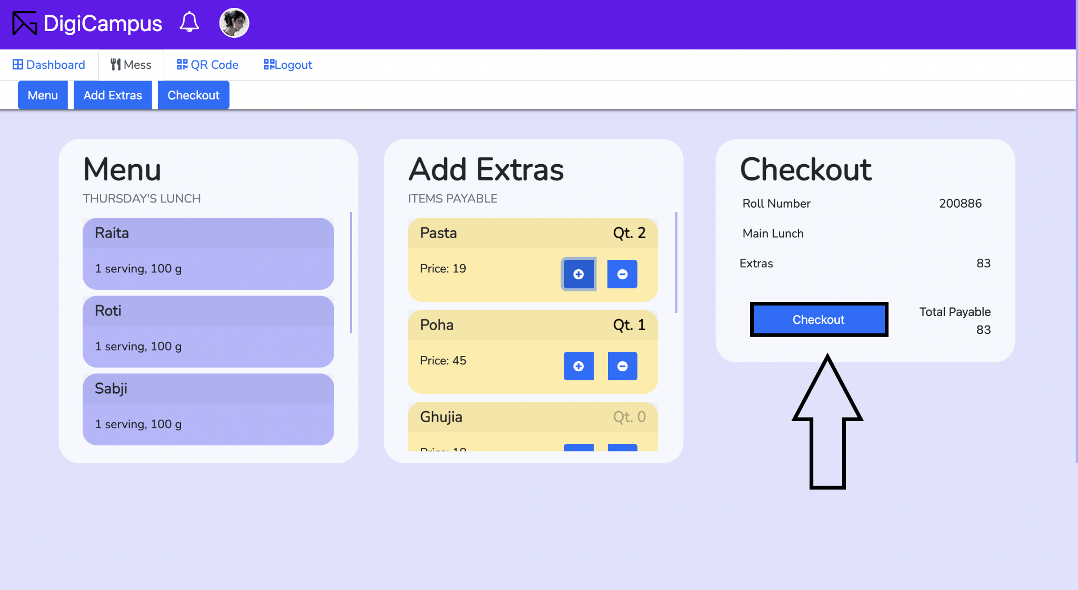

**Step 5:** Choose *Confirm* to place your order or *Cancel* to discard

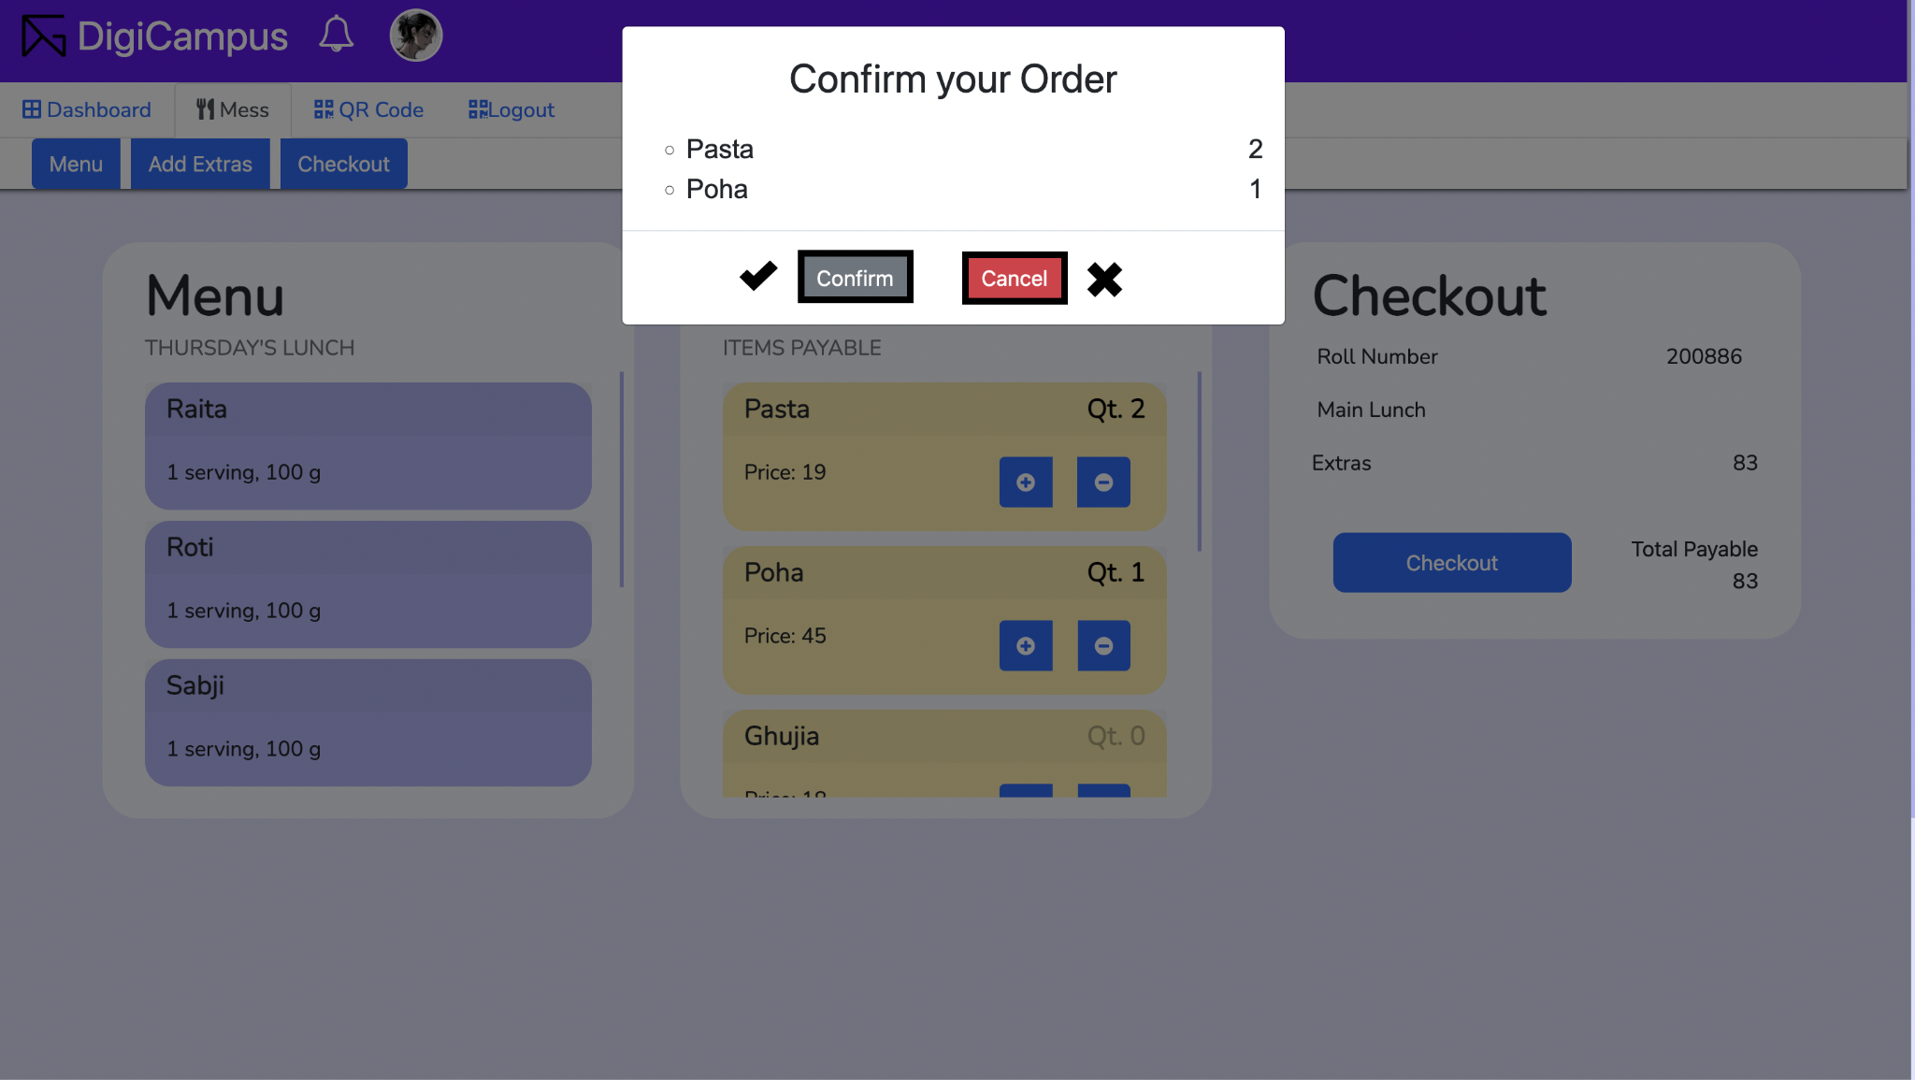

**Note:** On confirming, you will be redirected to the dashboard which shows your total expenses, last month's expenses and current expenses. You can also see a graph of your recent expenses.

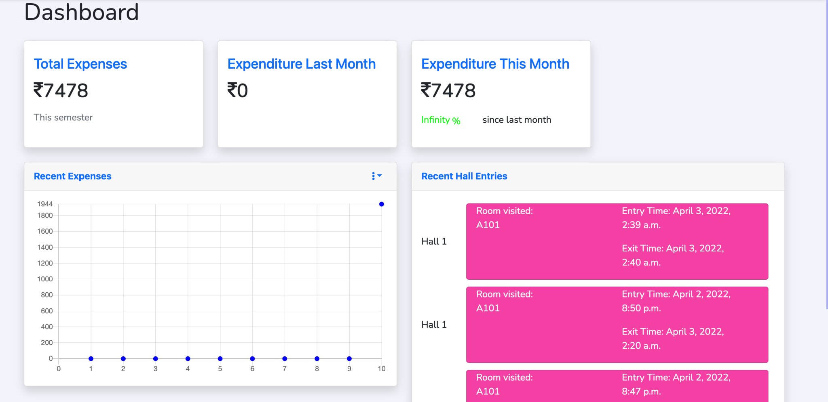

1. **Logout**

**Steps:** Click on *Logout* button on top navigation bar to logout of your account.

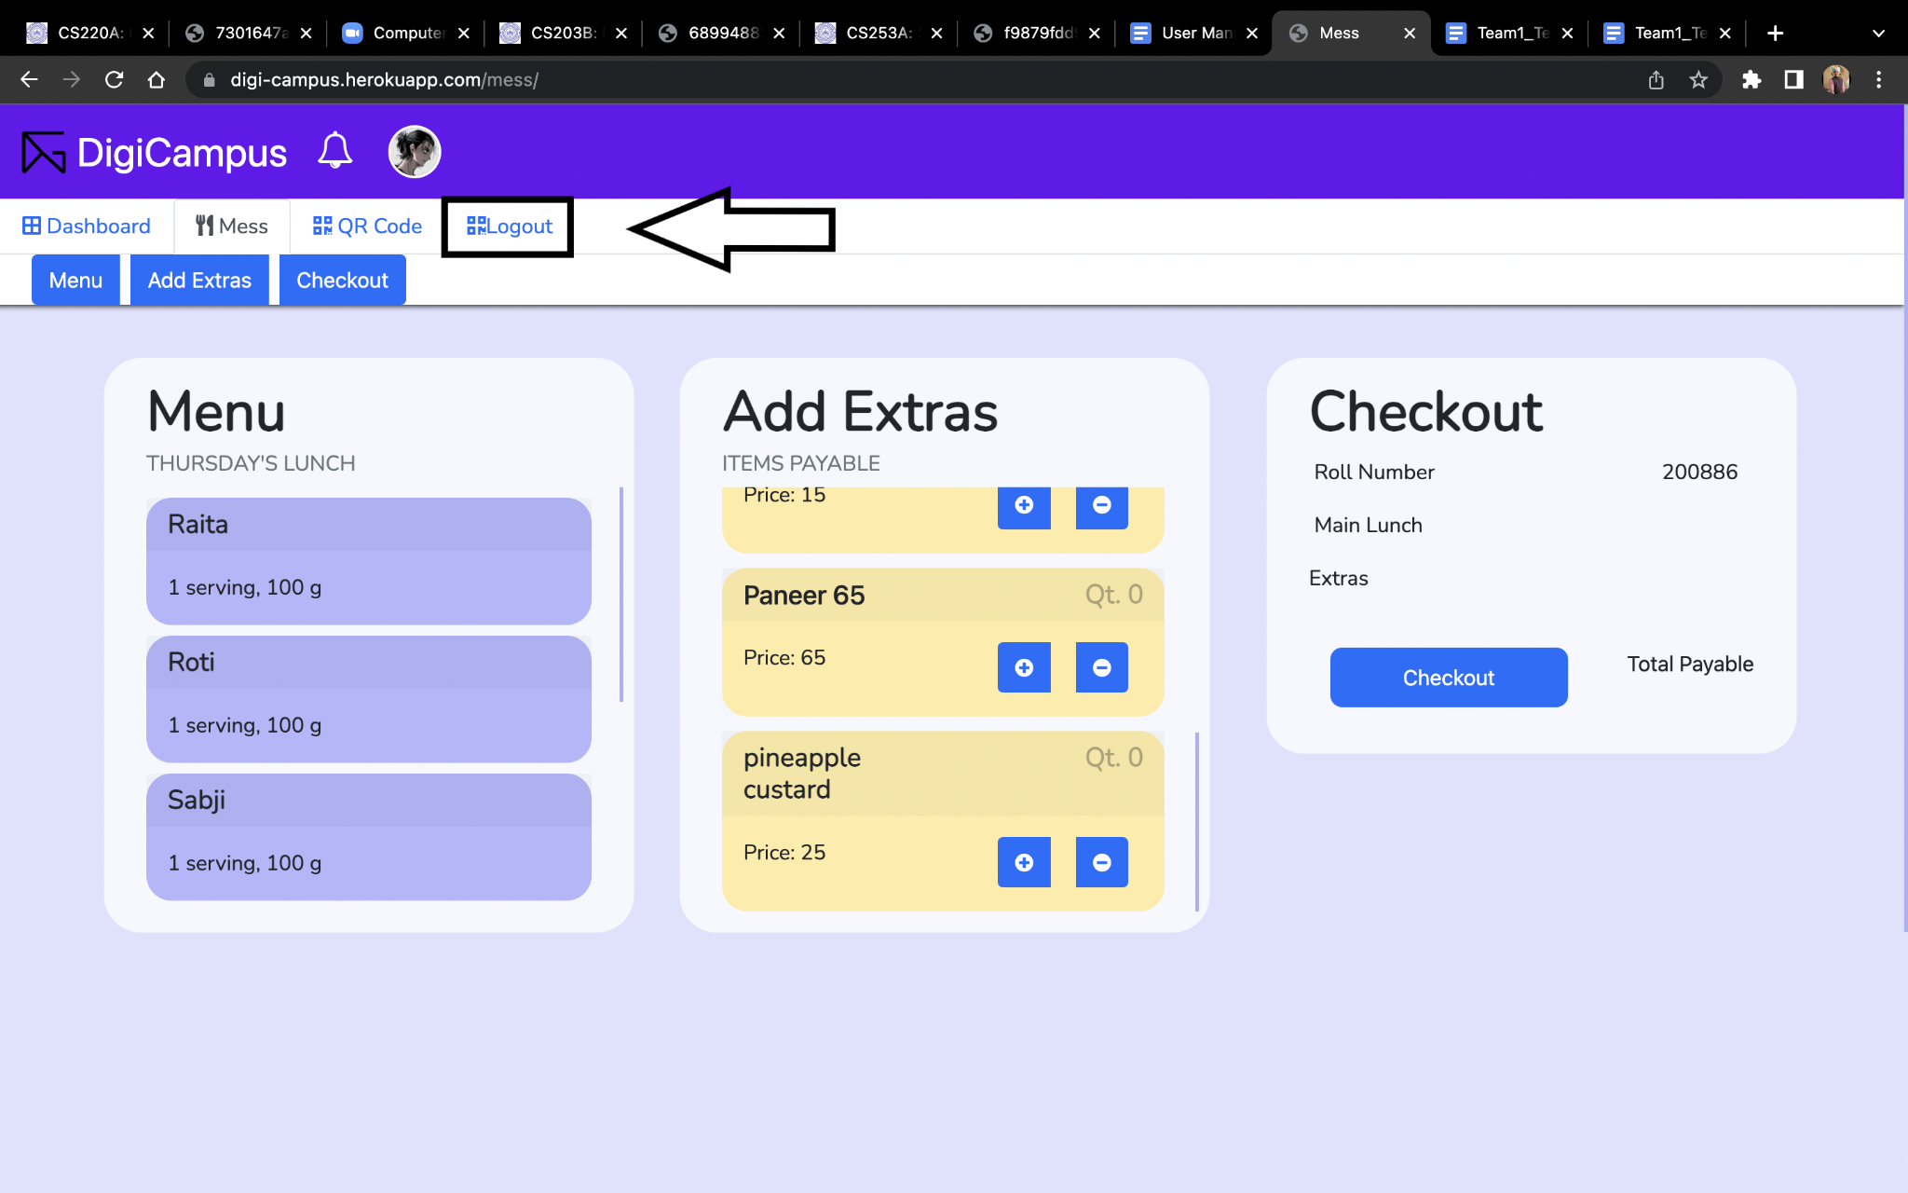

1. **Order History**

**Steps:** Click on *Order History* button to see the list of orders placed by the student. The time of ordering, the quantities of the items ordered and the price are displayed in chronological order.

**Mess Manager:**

1. **Login to your DigiCampus Account**

The Mess Manager will be provided with an initial user id and password.

**Step 1:** Access **DigiCampus** at <https://digi-campus.herokuapp.com/>



**Step 2:** Enter your *Username* and *Password*.



**Step 3:** Click on *Login* button.



**Note:** In case of no input or incorrect input of user/password, the following warning messages

will pop up, respectively.

 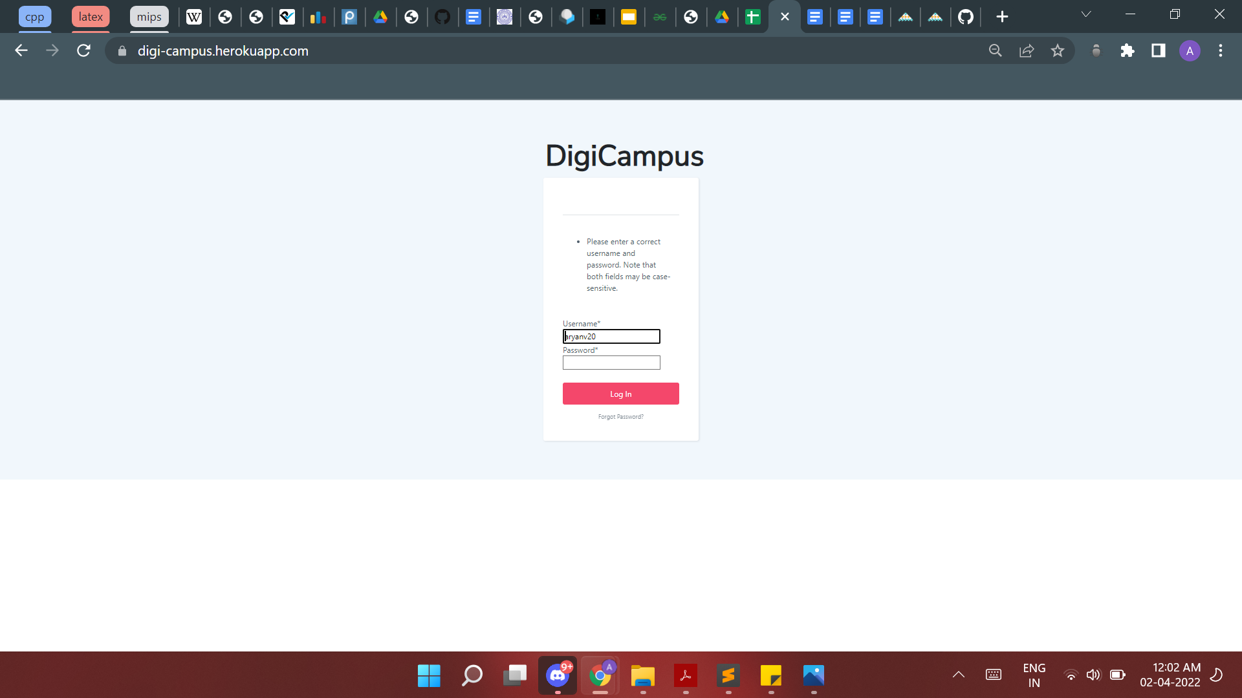

1. **Manage Menu**

**I. Add item**

**Step 1:** Enter the item name in the space provided

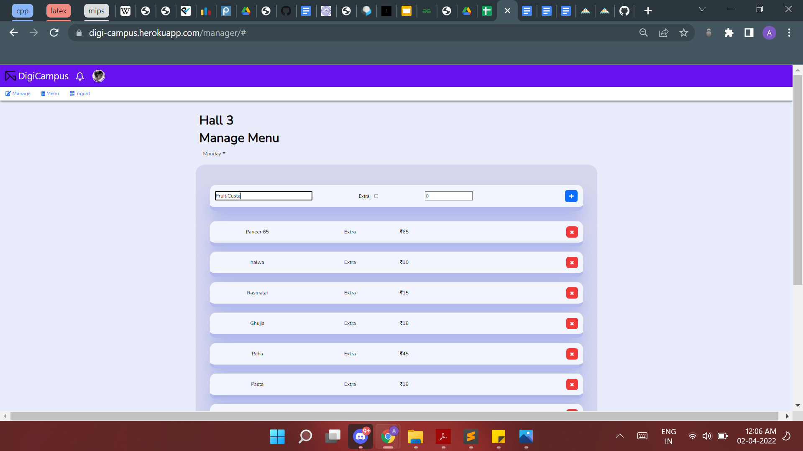

**Step 2:** Tick the checkbox if the given item is to be added in extras of the menu

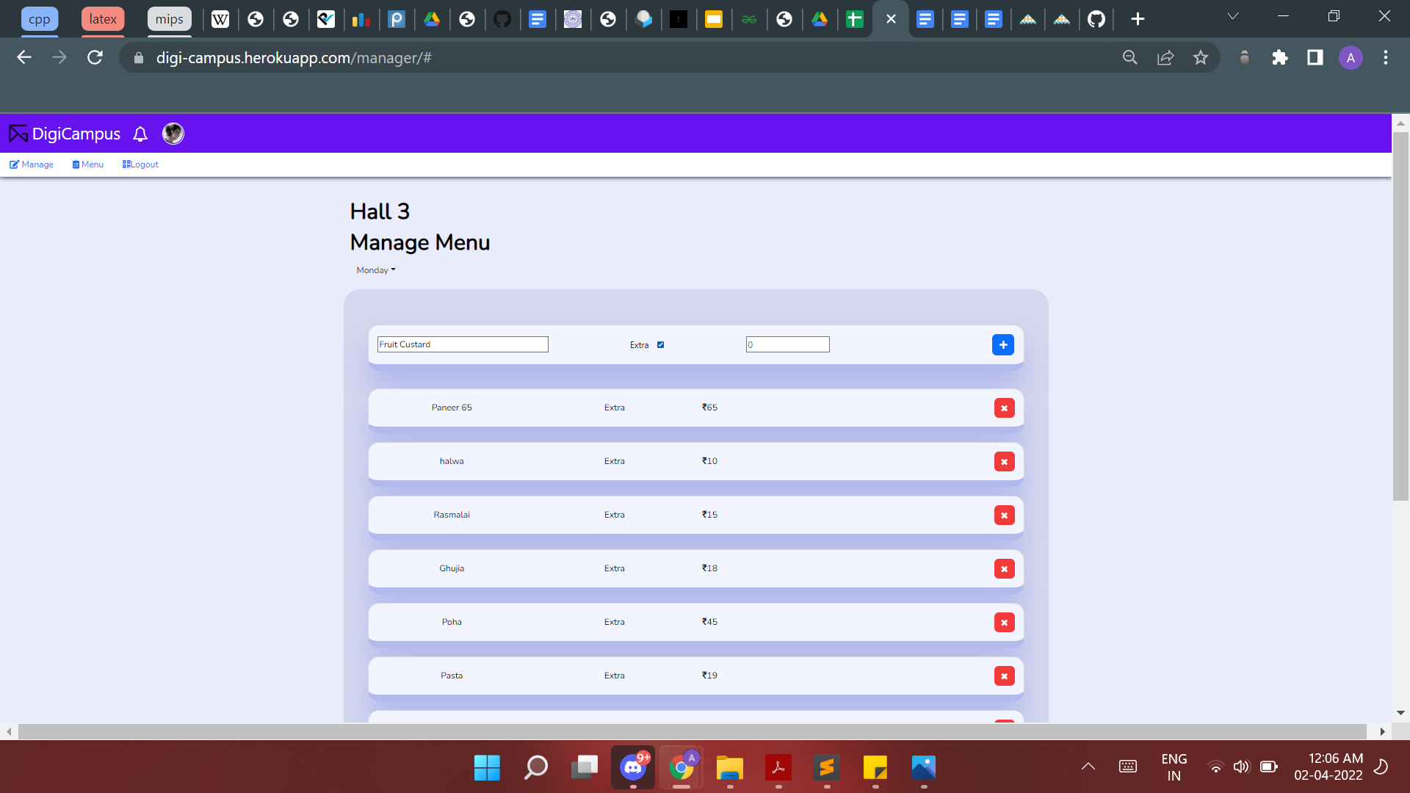

**Step 3:** Enter the price of the item by either typing in the given space or by using the

increase/decrease value arrows provided

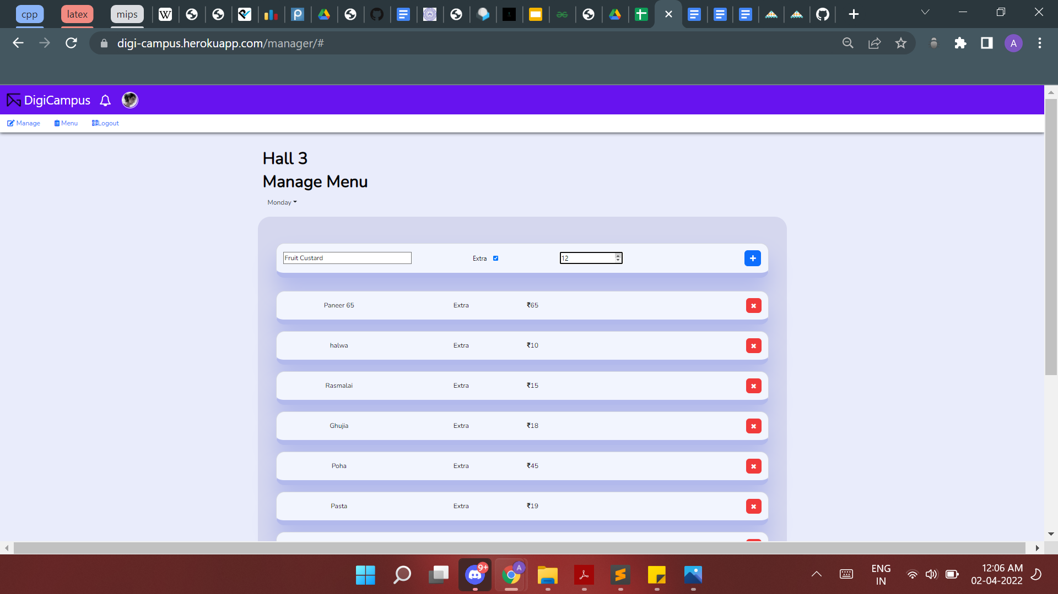

**Step 4:** Click on the blue “+” button on the right to add the item to the menu.

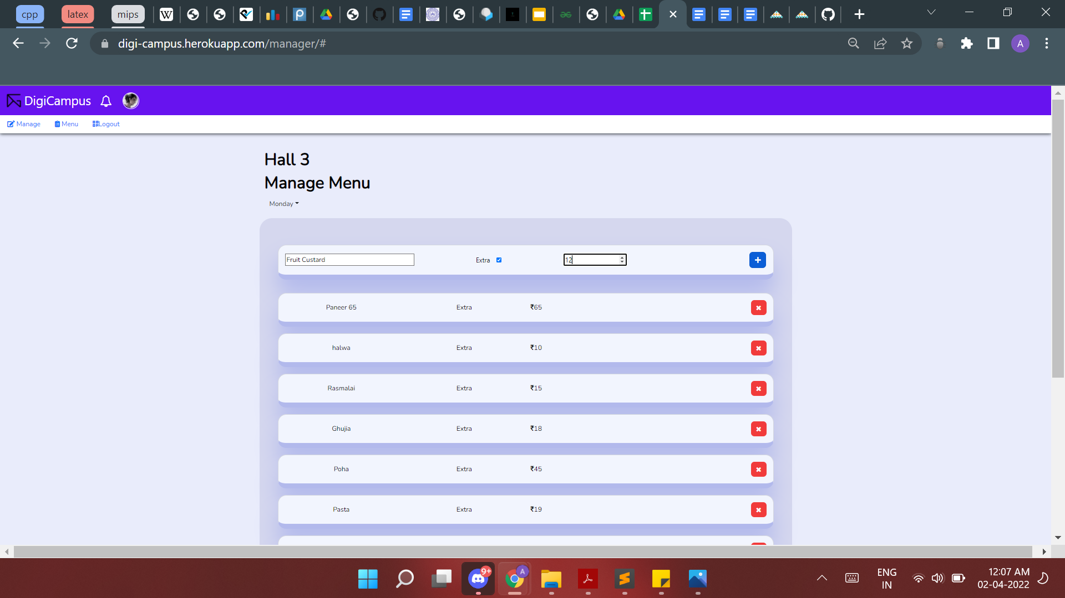

This item will now be available in the *Student Profiles* :

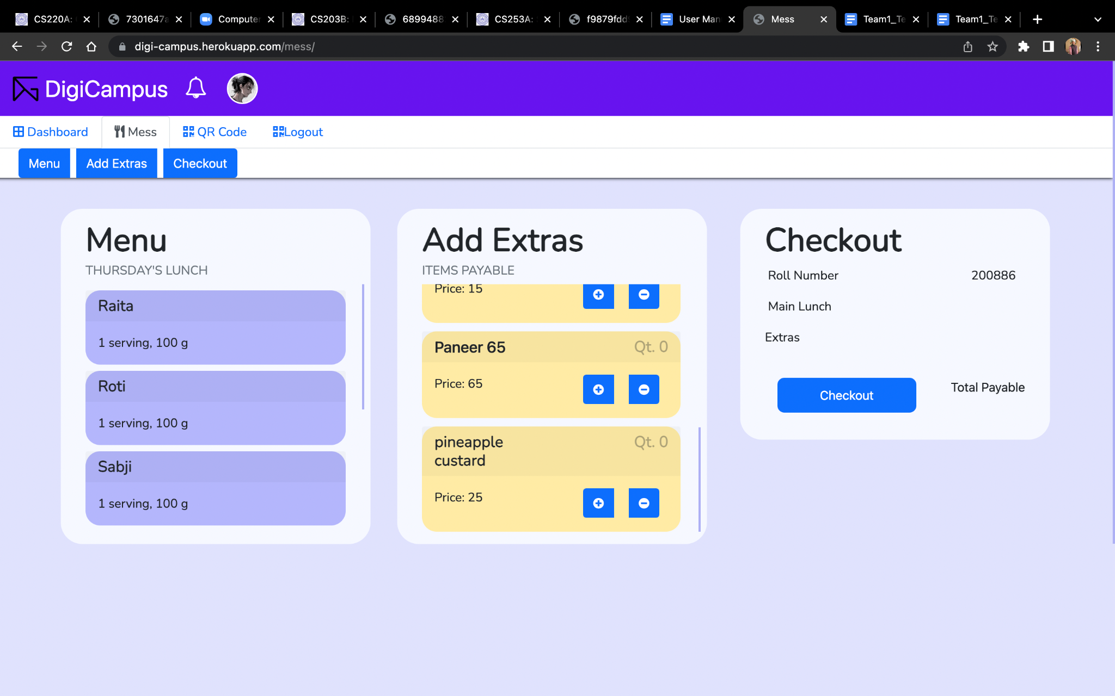

**II. Delete item**

**Step 1:** Find the item to be deleted by scrolling through the menu.

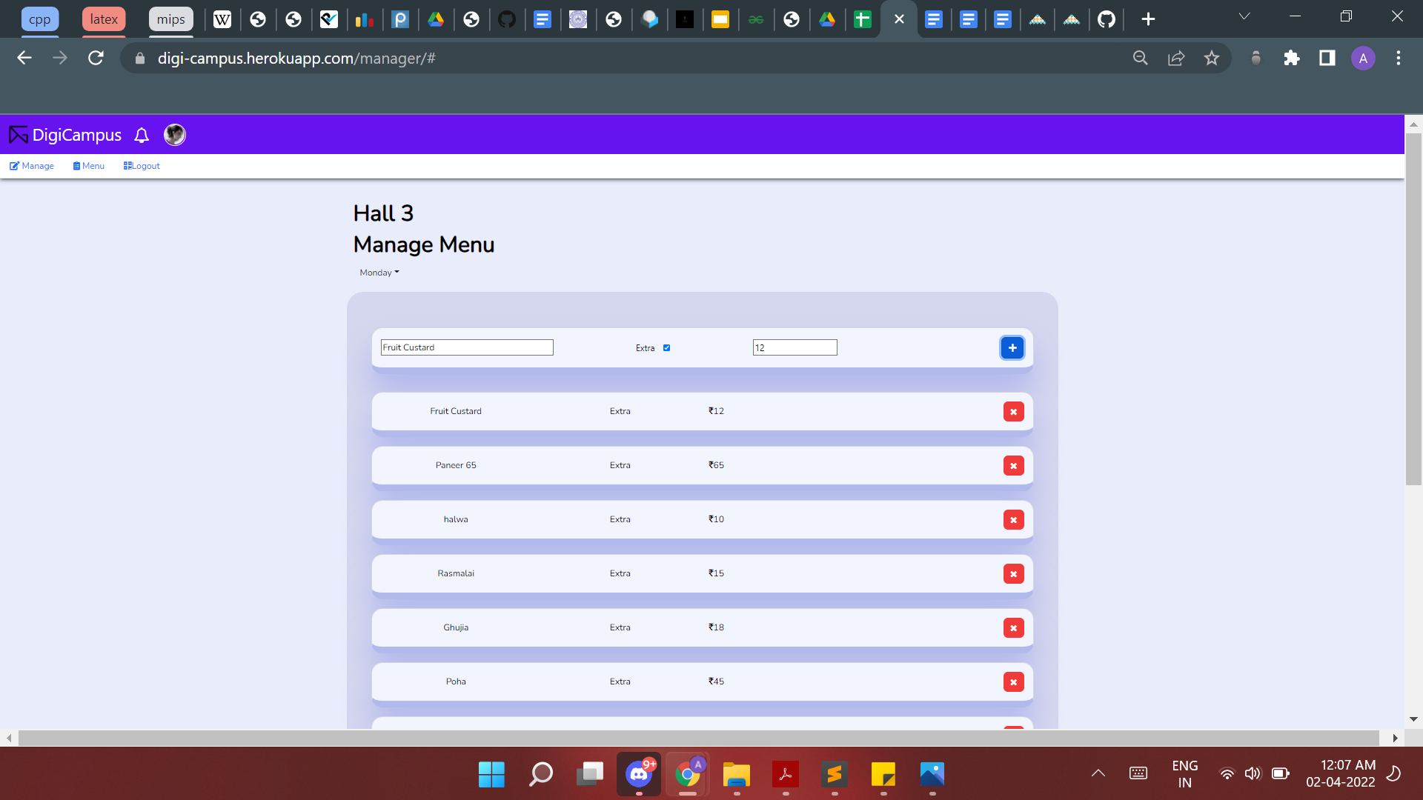

**Step 2:** Click on the *red cross* button to the right of the item to be deleted



And similarly the item would be deleted from the Menu visible to students in their *Student Profiles*.

1. **Logout**

**Steps:** Click on *Logout* button on the top navigation bar to logout of your account.

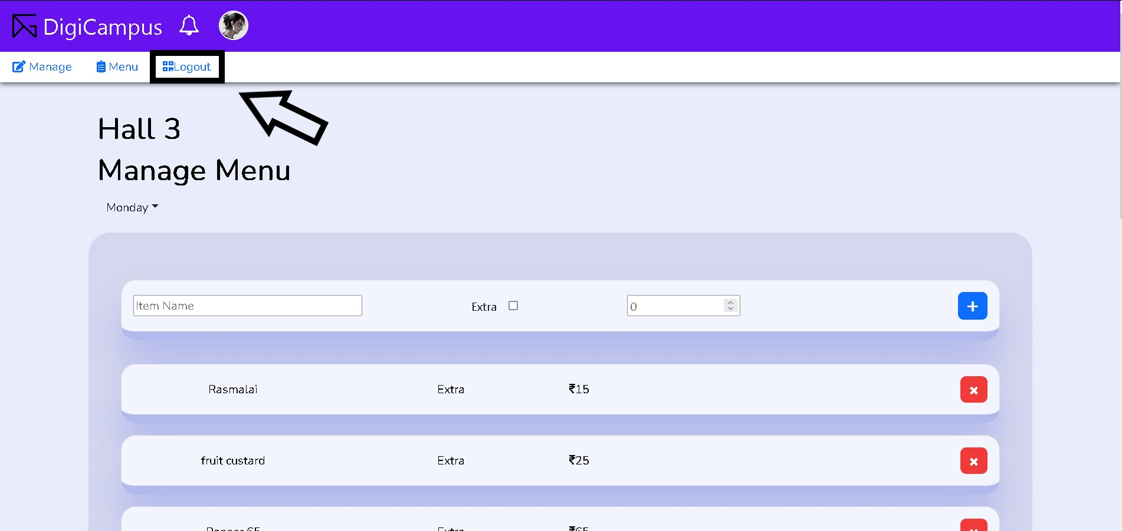

**Security Guard:**

1. **Login to your DigiCampus Account**

The User will be provided with an initial user id and password.

**Step 1:** Access the website at <https://digi-campus.herokuapp.com>.



**Step 2:** Enter *Username and Password*



**Step 3:** Click on Login button



**Note:** In case of no input or incorrect input of *User/Password*, the following warning messages will pop up, respectively.

 

**2. Managing Entry/Exit at Hall Gate**

**Step 1:** Click on the *Select Hall* button displayed on top left

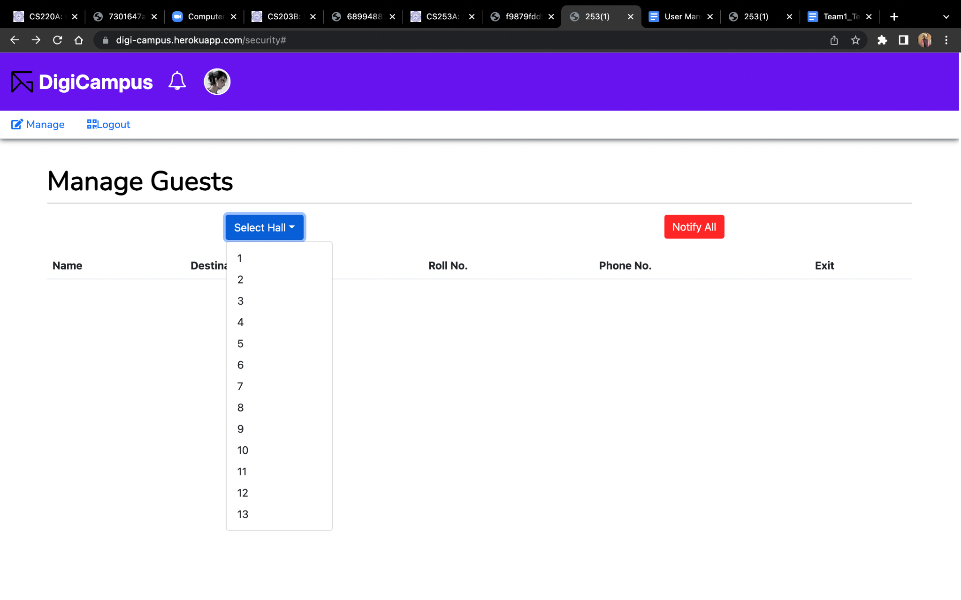

**Step 2:** From the dropdown then visible, select the hall whose guest list you wish to view. A list with all the details of students who are visiting that Hall would be visible

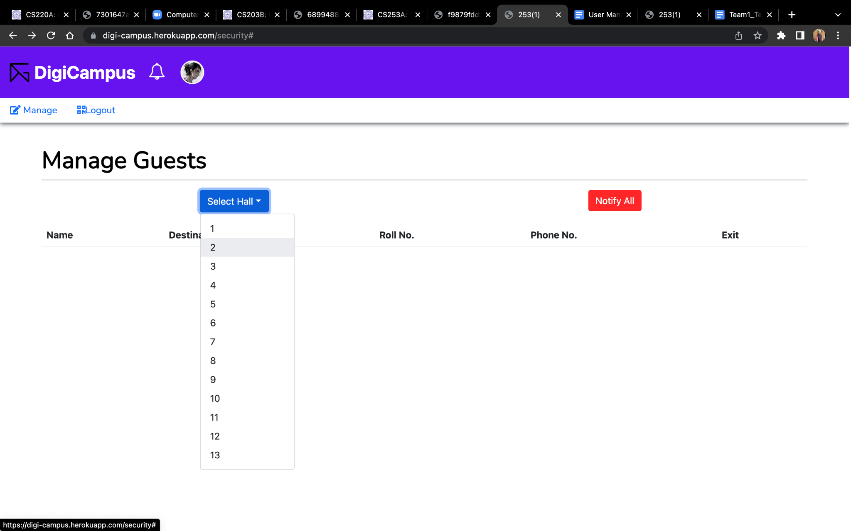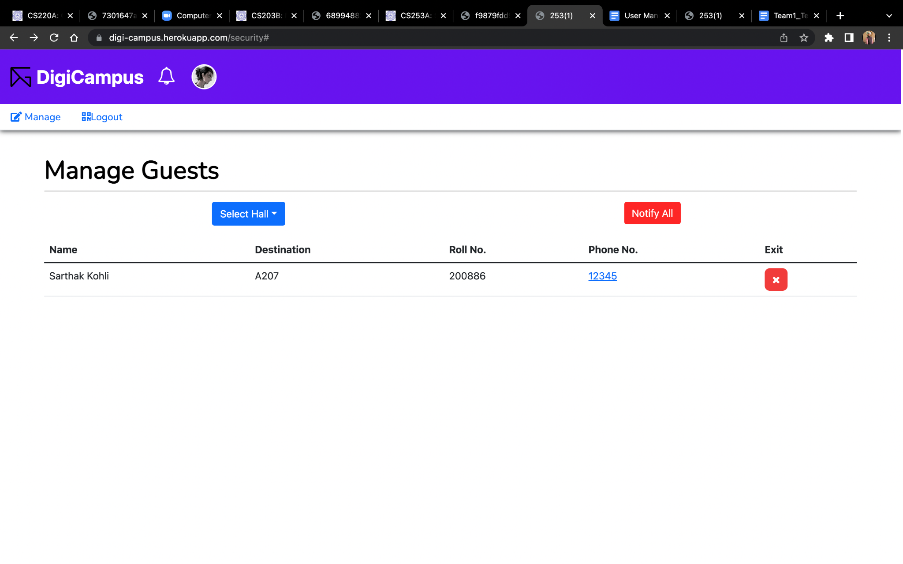

**Step 3:** To mark the exit of student, click on the *red cross*  present at the right of the row

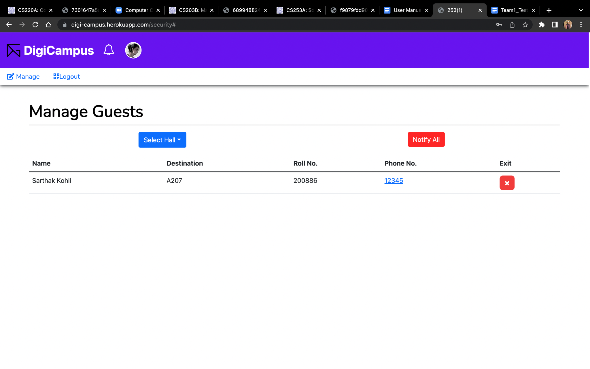

**3. Contacting students**

**Step 1:** Click on the *Phone No.* in 4th column in front of student’s name

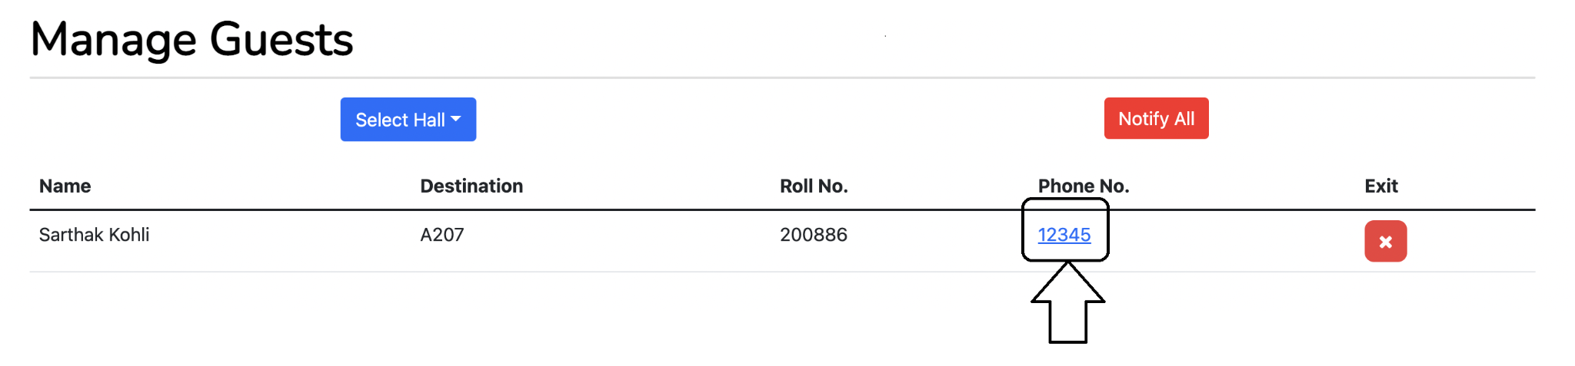

**Step 2:** Choose a mobile app to place call

**4. Logout**

**Steps:** Click on *Logout* button on top navigation bar to logout of your account.

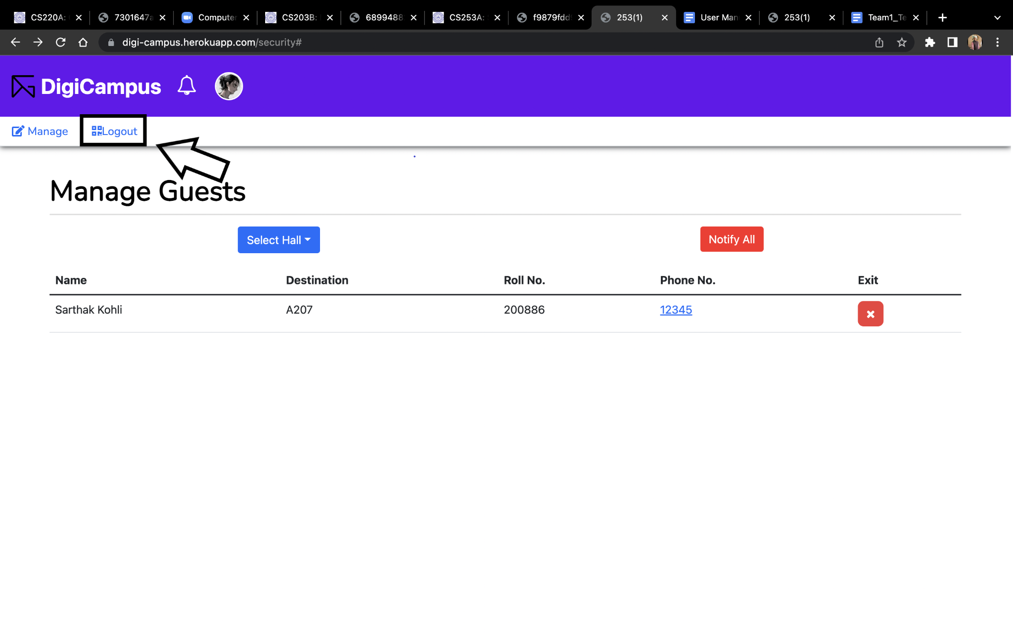

**Appendix A - Group Log**

23-03-22: Aryan explored testing methods for the Django framework

24-03-22: Dishay explored testing the frontend functionalities.

29-03-22: Samarth and Sarthak fixed authentication bugs.

30-03-22: Samarth fixed the bug in which Hall entry time was being saved in UTC

31-03-22: Sarthak fixed the interlinking of buttons from one view to other view.

1-03-22: Sarthak and Samarth fixed the bug that the hall entry/exit form was not getting refreshed after a failed event.

02-03-22: Dishay did integration testing of the mess and hall entry/exit module.

01-04-22: Aayush did work on testing functional requirements.

02-04-22: Aryan, Dishay, and Shashwat worked on Unit testing.

03-04-22: Shashwat worked on Scheduler testing.

02-04-22: Dishay and Aryan worked on Module Testing.

02-04-22: Aryan worked on System Testing.

23-03-22-03-04-22: Sarthak and Samarth sorted out bugs found during testing as well as minor improvements to the project.

23-03-22-03-04-22: Girik, Ananya and Ankur worked on User Manual.

26-04-22: Ananya and Girik updated Version 2.0 of User Manual